🚨Destination Certification CISSP TLDR 🚨

1) Protect society, the common good, necessary public trust and confidence, and . the infrastructure.
2) Act honorably, honestly, justly, responsibly, and legally.
3) Provide diligent and competent service to principals.
4) Advance and protect the profession.

Confidentiality: Prevents unauthorized access.
Integrity: Ensures data is accurate.
Availability: Ensures data is accessible.
Authenticity: Verifies identity or source.
Nonrepudiation: Proves actions occurred.

Scoping: Selecting relevant controls. (Selecting In-Scope Controls)
VS.
Tailoring: Customizing selected controls. (Refines and Enhances Controls)
VS.
Baselining: Establishing a security standard. (Using the scoped and tailored controls)

Accountability: Ultimate ownership and liability; Sets rules and policies; Can only be one person.
VS
Responsibility: Delegated ‘Do-er’ of a task/process; Develops plans/implements controls. Can be multiple people.

Due Diligence: ‘Do Detect’ - The ability to prove Due Care to stakeholders, Upper Management, Regulators, Customers, Shareholders, etc. (Research / Planning)
VS
Due Care: ‘Do Correct’ and ‘Prudent Man’ - Accountable protection of assets in alignment with business goals and objectives (Fixing / Correcting)

Sensitive Data = PII, PHI, SPI, PCI, or Intellectual Property (IP)

Data Owners: Decide data use and access. (Accountable Entity)
Data Custodians: Maintain and protect data. (Technical Responsibility)
Data Controllers: Decide why/how data is used.
Data Processors: Handle data for controllers. (Processing Responsibility)
Data Stewards: Handle Data Quality, Compliance, etc. (Business Responsibility)
Data Subjects: People the data is about or referencing.
🚨Destination Certification CISSP TLDR 🚨

(EU) GDPR: Regulates EU personal data protection.
(US) GLBA: Protects financial customer data. (Annual Privacy Notification)
(US) HIPAA: Secures health data and privacy.
(US) SOX: Ensures financial reporting integrity.
(US) COPPA: Protects children's online data. (Max Age of 13 years old)
(US) CCPA: Grants Californians data privacy rights.
(US) California Privacy Rights Act of 2020: Expands and enforces CCPA rights.
(Canada) PIPEDA: Governs private-sector data use.
(China) PIPL: China’s strict personal data law.
(South Africa) PPIA: Safeguards personal data processing.
(Argentina) PDPL: Protects personal data rights.
(South Korea) PIPA: Regulates personal data collection/use.
(Australia) Privacy Act: Governs handling of personal information.
(Australia) APPs: Privacy principles under Privacy Act.

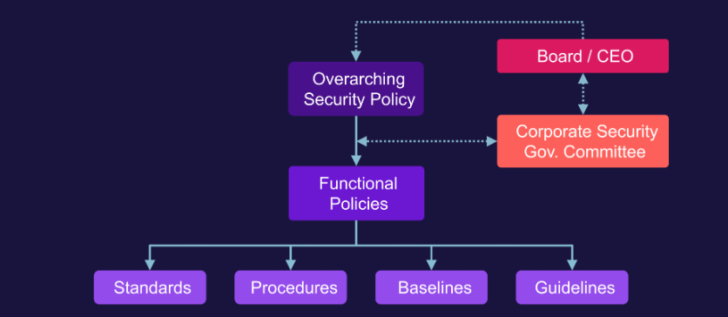
Policies: High-level rules and expectations. (Mandatory)
Standards: Mandatory, specific requirements. (Mandatory)
Procedures: Step-by-step implementation instructions. (Mandatory)
Baselines: Minimum acceptable security levels. (Mandatory)
Guidelines: Optional best-practice recommendations. (Optional)

🚨Destination Certification CISSP TLDR 🚨

Risk Management: The identification, assessment, and prioritization of risks and the economical application of resources to minimize, monitor, and control the probability and/or impact of these risks.

Risk: Significant Asset exposure to a Threat or Vulnerability
- Risk = Threat x Vulnerability x Impact
- Risk Probability / Likelihood = Threat x Vulnerability

Risk Management Steps:
1) Value: Identify and prioritize assets. (AKA Asset Valuation)
- Qualitative Value Analysis: Company Reputation
- Quantitative Value Analysis: AV, EF, ARO, SLE, ALE
2) Risk Analysis: Determine risk associated with each asset using 4 key components
- Threat: Any potential danger to an Asset (ie: flood, hacker, data breach)
- Vulnerability: A weakness that could be exploited by an attacker
- Impact: The extent to which an Asset would be affected
- Probability/ Likelihood: The chance for a Risk to materialize/realize
3) Treatment: Decide and apply risk responses using 4 treatment methods
- Avoid: NOT doing the risky activity in the first place
- Transfer: Purchase an Insurance Policy (ie: Cyber Insurance)
- Mitigate: Implement Controls to reduce the Risk
- Accept: The Asset Owner accepts a certain level of risk(Cost/Benefit Analysis)

PDCA “Deming Cycle”: Risk management is a continuous, arduous, and time-consuming process that needs to be continually updated. (REPEATS)

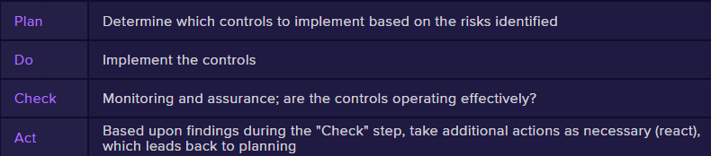

🚨Destination Certification CISSP TLDR 🚨

Functional: Control must do what it is designed to do
Assurance: Control can be evaluated to confirm functionality (proof and confidence)

NIST SP 800-37 RMF: Federal operational security governance within an organization.
1) Prepare: Get ready for RMF activities.
2) Categorize: Inventory and Classify Systems / data by sensitivity level and impact.
3) Select: Choose baseline security controls. (Cost/Benefit discussion of Controls)
4) Implement: Apply chosen security controls and document updated Baseline
5) Assess: Evaluate control effectiveness + Review/ Approval of a comprehensive plan
6) Authorize: Approve system operation risk. (Certification and Accreditation)
7) Monitor: Continuously check control status in Real-Time

STRIDE: Microsoft threat model for identifying attack types.
Spoofing: Pretending to be someone else.
Tampering: Altering data or code.
Repudiation: Denying actions without proof.
Information Disclosure: Leaking confidential data.
DoS: Disrupting system availability.
Elevation of Privileges: Gaining unauthorized access rights.

PASTA: Risk-centric threat modeling methodology.
1) Define Objectives: Set business and security goals.
2) Define Technical Scope: Identify system components.
3) Application Decomposition: Map data flows and functions.
4) Threat Analysis: Identify potential threats.
5) Vulnerability and Weakness Analysis: Spot system flaws.
6) Attack Modeling: Simulate threat actor behavior.
7) Risk and Impact Analysis: Evaluate risk to assets.

DREAD: Risk assessment model for rating threats.
Damage: How severe the impact is. (Scored 1-10 *10 being the highest risk rating*)
Reproducibility: How easily the attack repeats.(Scored 1-10)
Exploitability: How easy it is to launch. (Scored 1-10)
Affected Users: How many users are impacted. (Scored 1-10)
Discoverability: How easy it is to find the flaw. (Scored 1-10)

🚨Destination Certification CISSP TLDR 🚨

SLA(Service Level Agreement): Defines expected service performance.
SLR(Service Level Requirements): Customer’s specific service needs.
MOU(Memorandum of Understanding): Informal agreement between parties.
NDA(Non-Disclosure Agreement): Protects shared confidential information.
NCA(Non-Compete Agreement): Prevents competition after departure.

Awareness: Informs of basic security topics.
Training: Teaches specific security skills.
Education: Provides deep security understanding.

⭐Security Functions and Controls should align with Business Strategy

Data Classification Process (CYCLICAL)
1) Asset Inventory.
2) Determine and Assign Ownership.
3) Classify based on Value.
4) Protect and Handle based on Classification.
5) Assess and Review.
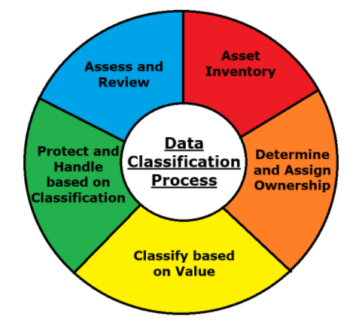
🚨Destination Certification CISSP TLDR 🚨

Classification: System of classes ordered according to value (sensitivity)
VS
Categorization: The act of sorting into defined classification levels

Labeling: System-Readable, used to enable System-Based Enforcement
VS
Marking: Human-Readable, used to enable Process-Based Enforcement

Data Life Cycle: Stages of data from creation to disposal.
1) Create: Generate, Update or collect data. (CLASSIFICATION ASSIGNED HERE)
2) Store: Save data securely.
3) Use: Access or process data.
4) Share: Distribute data appropriately.
5) Archive: Retained for long-term storage. (Following Retention Policies)
6) Destroy: Permanently delete data.
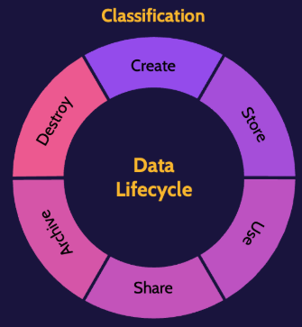

🚨Destination Certification CISSP TLDR 🚨

Data Sanitization: Process to securely remove data. (Umbrella Term)
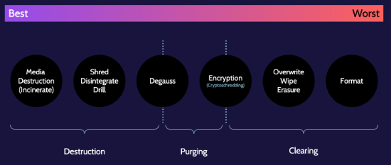
Clearing:
- Formatting: Prepares storage but doesn’t fully erase data.
- Erasure: Deletes data using software methods.
- Wiping: Overwrites entire drive with random data.
- Overwriting: Replaces data with new data patterns.

Purging:
- Crypto Shredding(Clearing & Purging): Deletes encryption keys to make data unreadable.
- Degaussing(Purging and Destruction): Uses magnets to erase magnetic storage.

Destruction:
- Shred: Cuts media into small pieces.
- Drill: Punches holes through media.
- Disintegrate: Pulverizes media into dust.
- Incinerate: Burns media to ash.

End-to-End Encryption: Encrypts data from sender to receiver only.
Link Encryption: Encrypts data between each network hop.
Onion Network: Layers encryption through multiple relays (e.g., Tor).

DRM: Controls access and usage of digital content. (Protects Movies, Videos, Music, eBooks, Cable and Satellite Service Providers)
IRM: Controls access and usage of digital content. (Specifically Documents)
DLP: Prevents unauthorized data disclosure or transfer. (Usually from internal)
🚨Destination Certification CISSP TLDR 🚨

Zero Trust: Never trust, always verify—authenticate everything.
Principles of Zero Trust:
- Know your Architecture
- Know your User, Services, and Device Identities
- Know the Health of your Users, Devices, and Services
- Use Policies to Authorize requests
- Authenticate EVERYWHERE
- Focus your Monitoring on Devices and Users
- Do NOT Trust any network, INCLUDING your own!
- Choose Services designed for Zero Trust

Privacy by Design (PbD): Builds privacy into systems from the start.
- Proactive, not Reactive (Preventative, not Remedial)
- Privacy as the Default Setting (Implicit Deny)
- Privacy Embedded into System Design (Privacy as early as possible)
- Full Functionality (Win-Win for all parties involved)
- End-to-End Security (Cradle to Grave Security)
- Visibility and Transparency (Keep your promises, Be Sincere)
- Respect for User Privacy (User-Centric consideration at all times)

Cyber Kill Chain: 7-step model for understanding and stopping cyberattacks.
1) Reconnaissance: Gather target information.
2) Weaponization: Create attack payload.
3) Delivery: Transmit payload to victim.
4) Exploitation: Trigger the malicious code.
5) Installation: Install backdoor or malware.
6) Command and Control (C2): Establish attacker communication.
7) Actions on Objectives: Achieve attacker goals (e.g., exfiltration).

Layer / Lattice-Based Security Models: Use levels or hierarchies to control access.
- Bell-LaPadula: Enforces confidentiality (no read up, no write down).
- Biba: Enforces integrity (no write up, no read down).

Rule-Based Security Models: Use rules or conditions for access and integrity.
- Clark-Wilson: Enforces integrity via well-formed transactions.
- Brewer-Nash ("Chinese Wall"): Prevents conflicts of interest in access.
- Graham-Denning: Defines secure object management operations.
- Harrison-Ruzzo-Ullman: Formal model for access rights with subjects/objects.
🚨Destination Certification CISSP TLDR 🚨

Certification: Comprehensive Technical Analysis of a solution or product to ensure it meets the desired needs
VS
Accreditation: Official Management signoff/approval of Certification on a solution or product to operate with accepted risk for a set period of time

TCSEC (Orange Book): U.S. standard focused on confidentiality-based system classification.
A1 - D1 = Functional Levels
A1 - Verified Design
B3 - Security Labels, Verification of no covert channels, secure during start-up
B2 - Security Labels and Verification of no covert channels
B1 - Security Labels
C2 - Strict Login Procedures
C1 - Weak Protection Mechanisms
D1 - Failed or was not tested

ITSEC: European standard evaluating confidentiality, integrity, and availability separately.
EAL1 - EAL7 = Assurance Levels
Also uses the same Functional Levels as TCSEC (Orange Book)
EAL1 - Formal End-to-End security tests + Source Code Reviews
EAL2 - Semi-formal system + Unit tests and Source Code Review
EAL3 - Semi-formal system + Unit tests
EAL4 - Informal system + Unit tests
EAL5 - Informal system tests
EAL6 - System in Development
EAL7 - Inadequate Assurance

Common Criteria(ISO 15408): Global standard for evaluating IT product security.
- Protection Profile (PP): Independent security requirements for a product type.
- Target of Evaluation (ToE): Product or system being assessed.
- Security Targets (ST): ToE’s claimed security features and functions.
- Security Functional Requirements: What security the product must do.
- Security Assurance Requirements: How thoroughly the product is tested.
- Evaluate: Assess ToE against criteria.
- Assign EAL1–EAL7: Rate assurance level from minimal (EAL1) to formal verification (EAL7).
🚨Destination Certification CISSP TLDR 🚨

Common Criteria(ISO 15408) Assurance Levels:
EAL1 - Formally Verified, Designed, and Tested
EAL2 - Semi-formally Verified, Designed, and Tested
EAL3 - Semi-formally Designed, and Tested
EAL4 - Methodically Designed, Tested, and Reviewed
EAL5 - Methodically Tested and Checked
EAL6 - Structurally Tested
EAL7 - Functionally Tested
COBIT: IT governance and control framework.
ITIL: IT service management best practices.
NIST SP 800-53: Federal security control catalog.
PCI DSS: Payment card data security standard.
ISO 27001: ISMS certification standard.
ISO 27002: Security control implementation guidance.
COSO: Enterprise risk and internal control framework.
HIPAA: Protects health data privacy and security.
FISMA: Requires federal systems to be secured.
FedRAMP: Cloud security standard for U.S. government.
SOX: Ensures integrity of financial reporting.
Trusted Computing Base (TCB): Set of components enforcing system security policies.
Reference Monitor Concept (RMC): Abstract model enforcing controlled access between subjects and objects.
- RMC Must Mediate ALL Access
- RMC Must be protected from modification
- RMC Must be verifiably Correct
- RMC Must Always be Invoked
Security Kernel: Core part of the TCB that implements the reference monitor and enforces security policies.
- Completeness: All access must go through the reference monitor.
- Isolation: Reference monitor must be protected from modification.
- Verifiability: Reference monitor must be testable and provable correct.

🚨Destination Certification CISSP TLDR 🚨

CPU Process (CYCLICAL):
- Fetch: Retrieve instruction from memory.
- Decode: Interpret the fetched instruction.
- Execute: Perform the operation or calculation.
- Store: Save the result back to memory or register.

Processor States:
- Supervisor State: Privileged mode for OS-level operations.
- Problem State: Restricted mode for user-level processes.
Volatile and Non-Volatile Storage: From MOST to LEAST Volatile
- CPU Registers
- CPU Cache
- RAM
- Virtual Memory / HDDs / SSDs / Physical Media

Abstraction: Hides complex backend details behind simplified interfaces.
VS
Virtualization: Creates simulated versions of hardware or environments.

Defense-in-Depth: Multiple layered security controls to protect assets.
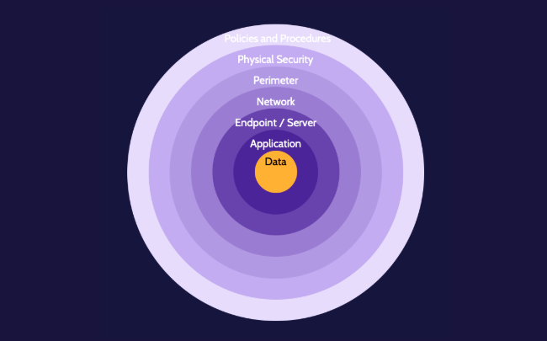
🚨Destination Certification CISSP TLDR 🚨

OWASP Mobile Top 10:
M1 - Improper Credential Usage
M2 - Inadequate Supply Chain Security
M3 - Insecure Authentication / Authorization
M4 - Insufficient Input / Output Validation
M5 - Insecure Communication
M6 - Inadequate Privacy Controls
M7 - Insufficient Binary Protections
M8 - Security Misconfiguration
M9 - Insecure Data Storage
M10 - Insufficient Cryptography

Grid Computing: Combines resources from multiple systems to work on a task.
Distributed Systems: Independent systems working together as one.
Big Data: Large, complex datasets requiring advanced processing.

(Umbrella Term) ICS (Industrial Control System): Systems managing industrial processes.
SCADA (Supervisory Control and Data Acquisition): Remote monitoring and control of industrial systems.
DCS (Distributed Control System): Real-time process control spread across multiple controllers.
PLC (Programmable Logic Controller): Ruggedized computers controlling industrial machines.

Virtual Machine: Emulates an entire operating system with its own kernel.
VS
Container: Isolates applications using the host OS kernel.

Cloud Consumer/Customer: Uses cloud services for business or personal needs.
Cloud Service Provider (CSP): Delivers and manages cloud services.
Cloud Service Partner: Supports cloud services through integration or development. (ie: Cloud Auditor or Cloud Service Broker)
Cloud Broker: Manages, negotiates, or aggregates services between consumers and CSPs.

🚨Destination Certification CISSP TLDR 🚨

SPML (Service Provisioning Markup Language): Automates user account provisioning across systems.
SAML (Security Assertion Markup Language): Exchanges authentication and authorization data between parties.
OAuth: Delegates access without sharing user credentials. (Authorization)
OpenID: Authenticates users using a third-party identity provider. (Authentication)

Ingress: Incoming network traffic to a system.
Egress: Outgoing network traffic from a system.
Peering: Direct interconnection between two networks for data exchange. (Exchange information without going through the internet, is very common with ISPs)

Cross-Site Scripting (XSS): Injects malicious scripts into trusted websites.
- Stored/Persistent: Malicious script is saved on the server and served to users.
Ex: User visits a specific webpage / image / post and XSS is executed
- Reflected/Nonpersistent: Script is in a URL or input and immediately echoed back. (Most Common) Ex: Executes when a Phishing Link is clicked
- DOM-Based: Script is executed by modifying the page’s Document Object Model in the browser. (Can be BOTH Stored/Persistent OR Reflected/Nonpersistent)
Cross-Site Request Forgery (CSRF or XSRF): Tricks users into executing unwanted actions on authenticated sites.

Cross-Site Scripting (XSS) | Cross-Site Request Forgery (CSRF)
Unwanted action performed on the user’s browser | Unwanted action performed on a trusted website
User’s browser (Client) runs malicious JavaScript code | Website (Server) executes a command from a trusted User’s Browser.
User Browser is Exploited | Web Server is Exploited

SQL Injection: Look for things like ‘ OR 1=1 - -

🚨Destination Certification CISSP TLDR 🚨

Plaintext: Unencrypted, readable data.
Ciphertext: Encrypted, unreadable data.
Cleartext: Readable data not encrypted, but may not be secret.
Key/Crypto Variable: Secret value used in encryption/decryption.
Key Clustering: When different keys produce the same ciphertext from the same plaintext.
Work Factor: Estimated time/resources to break encryption.
IV/Nonce: Random value used once to ensure uniqueness in encryption.
Confusion: Makes the use of the key so complex, that even when an attacker knows the statistics, it is still difficult to deduce the key (Hiding the Key+Ciphertext relationship)
Diffusion: Complicates the statistics of the Ciphertext, and makes it difficult to discover the key of the encryption process by spreading out the information of the key/message
Avalanche: Small change in input drastically changes output. (The IDEAL case is that a single bit change will result in 50% of the Ciphertext changing)

Substitution | Transposition
Characters are replaced with a different character  GUBBINS ➡️JXEELQV | The order of characters is rearranged  GUBBINS➡️BINBUGS

Synchronous: Encryption uses a continuous, real-time key stream (e.g., stream ciphers). Encryption / Decryption requests are performed immediately
Asynchronous: Encryption uses independently generated keys (e.g., public/private key pairs). Encryption / Decryption requests are processed in batches (Queued)

One-Time Pad (OTP): Unbreakable cipher using a truly random key used only once.
Stream Cipher: Encrypts data one bit or byte at a time.
Block Cipher: Encrypts fixed-size blocks of data at a time. (Block Modes on next page)

Steganography: Hides data within other, non-secret data (e.g., images).
Null Cipher: Hides plaintext in plain sight using patterns or positioning.

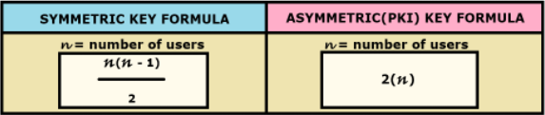
🚨Destination Certification CISSP TLDR 🚨

Symmetric Block Modes:
Name | Description | Characteristics / Keynotes
ECB (Electronic Codebook)  *Very Insecure; Very Fast* | Encrypts each block independently; weak against patterns. | Least Secure mode, but Fast!  Should only be used for short bits of random text that do not repeat, for example: PIN codes (No IV)
CBC (Cipher Block Chaining)  *Good for things like Email* | XORs each block with the previous ciphertext block. | Adds chaining to obscure patterns but is not parallelizable. (Has IV)
CFB (Cipher Feedback)  *Good for things like Email* | Turns block cipher into self-synchronizing stream cipher. | Turns block cipher into stream cipher; self-synchronizing. (Has IV)
OFB (Output Feedback)  *Good for things like Email* | Turns block cipher into synchronous stream cipher. | No error propagation; safe for noisy channels. (Has IV)
CTR (Counter)  *Best balance of speed and security*  *Most Common Mode of Block Cipher* | Encrypts a counter value for each block; highly parallelizable. | Fully parallelizable; great for high-performance use. (Uses Counter(a random number) that serves a similar purpose to an IV)

Advantages and Disadvantages of Symmetric Encryption:
Advantages (Pros) | Disadvantages (Cons)
- Fast and Efficient  - Strong | - Key Distribution  - Scalability  - No Authenticity, Integrity, or Nonrepudiation

Advantages and Disadvantages of Asymmetric Encryption:
Advantages (Pros) | Disadvantages (Cons)
- Solves Key Exchange Problem  - Enables Digital Signatures and other services like Authenticity (Proof of Origin), Confidentiality, and Access Control  - Solves Scalability Issue | - Significantly Slower  - Requires Large Key Sizes

🚨Destination Certification CISSP TLDR 🚨

Encryption Algorithms Defined and Graded by Security:

Name | Encryption Type | Overview | Strength Rating
DES | Symmetric | Uses a 56-bit key and 64-bit blocks; once a standard, now easily brute-forced due to small key size. | Weak
Skipjack | Symmetric | Developed by the NSA with an 80-bit key; originally used in the Clipper chip, now considered obsolete and untrusted. | Weak
SAFER | Symmetric | Designed for constrained devices like Bluetooth; limited key sizes and now outdated for modern security needs. | Weak
RC5 | Symmetric | Variable block size, key length, and number of rounds; simple but vulnerable to modern cryptanalysis. | Weak
3DES | Symmetric | Applies DES three times with two or three keys; stronger than DES but inefficient and deprecated due to performance and key size limitations. | Medium
CAST-128 | Symmetric | 64-bit block cipher used in PGP; supports keys from 40 to 128 bits and offers moderate protection. | Medium
IDEA | Symmetric | Uses a 128-bit key with strong resistance to differential and linear cryptanalysis; once used in PGP, now less common. | Medium
Blowfish | Symmetric | Fast and free 64-bit block cipher with variable-length key (up to 448 bits); strong for its time but surpassed by modern options. | Strong
RC6 | Symmetric | A more secure version of RC5; 128-bit block cipher and AES finalist; supports large key sizes and is resistant to known attacks. | Strong
Twofish | Symmetric | AES finalist with 128-bit block and up to 256-bit keys; known for flexibility, strong encryption, and open design. | Strong
El Gamal | Asymmetric | Based on Diffie-Hellman key exchange; provides confidentiality and supports digital signatures, though slower than RSA. | Strong
RSA | Asymmetric | Widely used for secure key exchange and digital signatures; relies on the difficulty of factoring large integers; ≥2048-bit key recommended. | Strong
AES | Symmetric | Advanced Encryption Standard; supports 128-, 192-, and 256-bit keys with 128-bit block size; the global standard for strong, efficient encryption. | Very Strong
ECC | Asymmetric | Elliptic Curve Cryptography; provides equivalent strength to RSA with much smaller key sizes; ideal for mobile, embedded, and IoT devices. | Very Strong

🚨Destination Certification CISSP TLDR 🚨

Asymmetric Algorithms for Key Generation and Exchange:
RSA | ECC | Diffie-Hellman
Based on factoring large integers.  Unique: Widely used for encryption and digital signatures.  Advantage: Proven and broadly supported.  Downside: Requires large keys and is slower than ECC. | Based on elliptic curve math.  Unique: Same security as RSA with much smaller keys.  Advantage: Faster and lightweight; ideal for mobile/IoT.  Downside: Newer; more complex to implement securely. | Based on discrete logarithms.  Unique: First public key exchange method.  Advantage: Secure way to establish shared secrets.  Downside: No authentication; vulnerable to MITM unless combined with other protocols.
Memory Aids:
- ECC > RSA for efficiency and smaller keys.
- RSA is more compatible.
- Diffie-Hellman is used for key exchange, not encryption or signing.

Hashing: Converts data into a fixed-length value that uniquely represents the input.
Key Elements of Hashing
- Fixed Length Digest: Output is always the same size.
- One Way: Can’t reverse the hash to get original data.
- Deterministic: Same input always gives the same output.
- Calculated on the Entire Message: Hash depends on all input bits.
- Uniformly Distributed: Outputs spread evenly across possible values.
- Collision Resistant: Hard to find two inputs with the same hash.

Hashing Algorithms:
- MD5: Fast but broken; not collision-resistant. (128-bit output)
- SHA1: Deprecated; vulnerable to collisions. (160-bit output)
- SHA2: Secure family (e.g., SHA-256); widely used.(224, 256, 384, or 512-bit output)
- SHA3: Newest standard; uses different math (Keccak). (224, 256, 384, or 512-bit output)

🚨Destination Certification CISSP TLDR 🚨

Digital Signatures: Prove message integrity and sender authenticity. (Provides Integrity, Authenticity, and Nonrepudiation)
VS.
Digital Certificates(X.509): Binds a public key to an identity. (Provides Authenticity and Trust—it verifies who owns a public key)

Digital Certificate Life Cycle:
1) Enrollment: Request a certificate from a Certificate Authority (CA).
2) Issuance: CA verifies identity and issues the certificate.
3) Validation: Check certificate status and authenticity.
4) Revocation: Certificate is invalidated before expiration.(Likely due to Compromise)
5) Renewal: Reissue certificate before it expires.

Certificate Authority(CA): Root of Trust
Registration Authority(RA): Identity proofs on behalf of the CA
Intermediate / Issuing CA: Issues Certificates on behalf of the CA
Certificate DB: List of Certificates issued by the CA + the Revocation List (CRL)
Certificate Store: Repository of Certificates / User’s Private Key on Local Machine

MIME: Adds support for attachments and rich content in email.(Images for example)

S/MIME: Adds encryption and Digital Signatures to email using certificates.(Provides Authentication, Nonrepudiation of Origin, Message Integrity, and Confidentiality)

SPF: Verifies the sender's mail server is authorized. (Provides sender validation—helps prevent spoofing, but no encryption or integrity.)

DKIM: Adds digital signature to verify sender domain. (Provides Integrity and Authentication of the sender’s domain via a Digital Signature.)

DMARC: Combines SPF and DKIM to enforce email policies. (Enforces policy for SPF/DKIM and provides reporting, helping to prevent phishing.)

🚨Destination Certification CISSP TLDR 🚨

Cryptanalytic Attacks |  | Cryptographic Attacks
Attack Name | Explanation | Attack Name | Explanation
Ciphertext Only | Attacker has only encrypted data. | MITM (AiTM) | Intercepts and alters communication between parties.
Known Plaintext | Attacker has some plaintext and matching ciphertext. | Replay | Reuses captured valid data to trick a system.
Chosen Plaintext | Attackers can encrypt data to study results. | Temporary Files | Attackers recover data from stored files.
Chosen Ciphertext | Attackers can decrypt selected ciphertexts. | Implementation | Exploits poor coding or system flaws.
Linear and Differential | Cryptanalysis using patterns in cipher behavior. | Side-Channel | Uses physical data (timing, power) to break encryption.
Factoring | Breaks encryption by factoring large numbers (RSA). | Dictionary | Try common passwords or phrases against hashes.
 |  | Rainbow Tables | Precomputed hashes used to reverse hashes quickly.
 |  | Birthday | Exploits hash collisions based on probability theory.
 |  | Social Engineering | Tricks people into revealing sensitive information.

Power / Voltage Changes:
 | Short Period of Time | Long Period of Time
No Power | Fault | Blackout
Low Voltage | Sag / Dip | Brownout
High Voltage | Spike | Surge

🚨Destination Certification CISSP TLDR 🚨

HVAC:
Temperature Range: 60 - 80F
- Too Hot: Overheating System Components
- Too Cold: Employees with complain
Humidity Range: 40% - 60%
- Too Humid: Condensation, Corrosion, Short Circuits
- Too Dry: Static Electricity
Air Quality: Air should be of good quality with low particles (Positive Pressure)
Fire + Fire Detection:
- Flame: Detect infrared and UV light created by a flame
- Smoke: “There is always smoke before a fire”
  - Ionization: Responds quickly to Flaming / Fast Fires
  - Photoelectric / Optical: Responds quickly to Smoldering Fires
  - Dual: Ionization + Photoelectric/Optical (Best of both worlds)
  - VESDA: Detects fire at Incipient(earliest) stage (BEST Detector)
- Heat: “Rate of Rise” Looks for rapid rise in temperature in a room/facility
Fire Suppression:
- Water-Based:
  - Wet Pipe: Water always in pipes; fast response.
  - Dry Pipe: Pipes fill with water only when triggered; prevents freezing.
  - Pre-Action: Water held back until fire is confirmed.
  - Deluge: All sprinklers open; massive water release.
- Gas-Based:
  - INERGEN: Inert gas mix; reduces oxygen to suppress fire.
  - Argonite: Argon/nitrogen mix; safe for equipment and people.
  - FM-200: Chemical gas; fast-acting and safe for electronics.
  - Aero-K: Aerosol agent; suppresses fire by interrupting combustion.
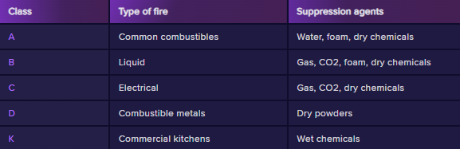
Ashes Boiling Current Dense Metals Kitchen
CO2: Not corrosive, too much can KILL PEOPLE (Use INERGEN, Argonite, FM200, Areo-K instead)
🚨Destination Certification CISSP TLDR 🚨

Consolidating Networking Model:
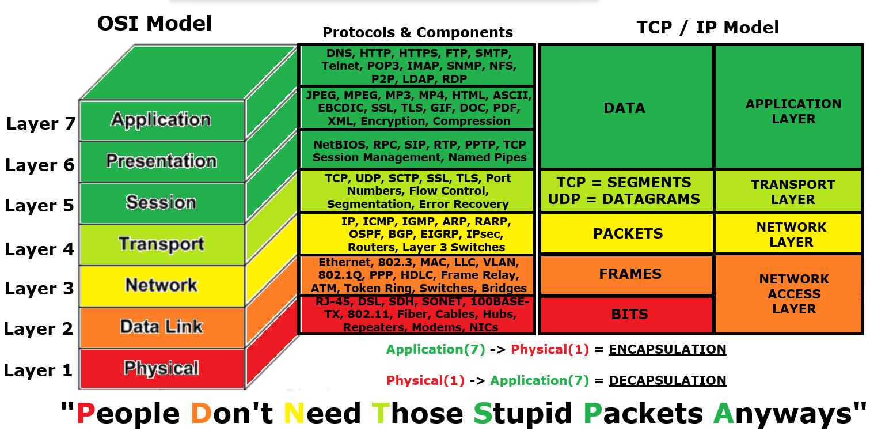
7 Application: | Identify capabilities of Applications and Resource Availability
6 Presentation: | Formatting of Data for the Application Layer
5 Session: | Interhost communication and Session Management
4 Transport: | End-to-End connection with error correction and detection
3 Network: | Logical Addressing, Routing, and Delivery of Packets
2 Data Link: | Physical Addressing, and reliable Point-to-Point connection
1 Physical: | Binary Transmission of Data across physical media (wire, fiber, etc.)

Bandwidth: Maximum data capacity of a link.
Throughput: Actual data transferred over time.
Signal-to-Noise Ratio: Strength of signal vs. background noise.
Latency: Delay in data transmission.
Jitter: Variation in packet arrival time.
🚨Destination Certification CISSP TLDR 🚨
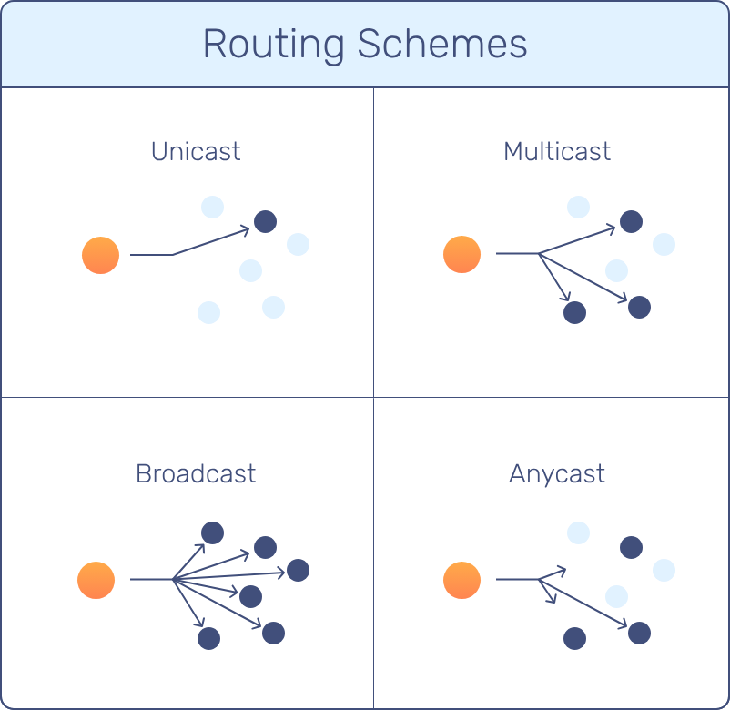
Unicast: One-to-One Multicast: One-to-Many
Broadcast: One-to-All Anycast: Nearest or Best Recipient

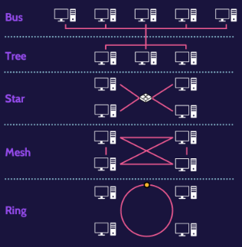
Bus: All devices share a single communication line. (Single Point of Failure or “SPOF”)
Tree: Hierarchical structure of star networks. (You can Isolate Branches of the Tree)
Star: Devices connect to a central hub or switch. (Most Common; Switch is SPOF)
Mesh: Devices are directly connected to many others. (Expensive, High Redundancy)
Ring: Devices form a closed loop; data travels in one direction. (Token Passing)

CSMA/CD: Detects collisions and retries (used in wired Ethernet).
CSMA/CA: Avoids collisions by signaling intent to send (used in Wi-Fi).
🚨Destination Certification CISSP TLDR 🚨

North-South Traffic: Traffic between internal network and external sources.
East-West Traffic: Traffic between internal devices or systems.

In-Band Management: Uses the same network as user traffic for management.
Out-of-Band Management: Uses a separate network for management access.
Air-Gapped Management: Physically isolated from all other networks.
VLANs: Logically separate networks on the same physical switch.
VPNs: Encrypted tunnels over untrusted networks.
VRF: Virtual routing tables on a single router.
Virtual Domains: Isolated virtual security zones within a device.
Layer 1 Physical: Transmits raw bits over physical media (cables, signals, voltages, connectors).
- Hub: Broadcasts data to all ports; no intelligence.
- Repeater: Boosts signal to extend range.
- Concentrator: Aggregates multiple connections into one.

Layer 2 Data Link: Manages MAC addressing and local delivery.
- L2F: Cisco tunneling protocol for VPNs; no encryption.
- PPTP (PAP, CHAP, and EAP): Tunneling with optional authentication; weak security.
- L2TP: Combines L2F and PPTP; supports IPsec for encryption.
- SLIP: Legacy protocol for serial IP connections; replaced by PPP.
- ARP (IP to MAC): Resolves IP address to MAC address.
- RARP (MAC to IP): Resolves MAC address to IP address.
- MAC Address: Unique hardware identifier burned into the device’s NIC
- Bridges: Connect and filter traffic between LAN segments.
- Switches: Forward frames based on MAC addresses; isolate collision domains.
Type | Client Authentication | Server Authentication | Security | Industry Support | Proprietary?
EAP-TLS | CERTIFICATE | CERTIFICATE | HIGH | HIGH | No
EAP-TTLS | ID & Password | CERTIFICATE | Medium | Medium | Yes
EAP-PEAP | ID & Password | CERTIFICATE | Medium | HIGH | Yes
LEAP | ID & Password | ID & Password | Low | HIGH | Yes
EAP-MD5 | ID & Password | N/A | Low | Low | No

🚨Destination Certification CISSP TLDR 🚨

Layer 3: Network: Handles routing and logical addressing (IP).
- ICMP: Sends error and status messages (e.g., ping).
- IGMP: Manages multicast group memberships.
- IPSec: Encrypts and authenticates IP traffic.
- IPv4: 32-bit IP addressing system.
- IPv6: 128-bit IP addressing system.
ARP: Resolves IP addresses to MAC addresses.

- BGP: Path-vector protocol used between ISPs.
- OSPF: Link-state routing protocol for internal networks.
- RIP: Distance-vector routing protocol using hop count.
- EIGRP: Cisco proprietary routing protocol combining features of distance-vector and link-state protocols.
- Packet Filtering Firewalls: Allow/deny traffic based on IP, port, protocol.
- Routers: Forward packets between different networks.
- Layer 3 Switches: Combine switching and routing functions.

LAN Technologies:
Wired | Wireless | Virtual LAN (VLAN)
IEEE 802.3  Ethernet standard for wired LANs. | IEEE 802.11  Wi-Fi standard for wireless LANs (WLAN) | IEEE 802.1Q  VLAN tagging standard for Ethernet frames.

IPv4 Network Classes (Subnetting):
Network Class | First Octet Range | CIDR | Subnet Mask | # of Hosts | Use Case
Class A | 1.x.x.x - 126.x.x.x | /8 | 255.0.0.0 | ~16.8M | Very Large Networks
Class B | 128.x.x.x - 191.x.x.x | /16 | 255.255.0.0 | 65,534 | Medium Networks
Class C | 192.x.x.x - 223.x.x.x | /24 | 255.255.255.0 | 256 | Small Networks
Class D | 224.x.x.x - 239.x.x.x | N/A | N/A | N/A | Multicast
Class E | 240.x.x.x - 255.x.x.x | N/A | N/A | N/A | Reserved/Experimental

🚨Destination Certification CISSP TLDR 🚨
Special IP Ranges:
Address Type | Range
PRIVATE IP: Class A | 10.0.0.0 - 10.255.255.255 💡Private A = 10.x.x.x
PRIVATE IP: Class B | 172.16.0.0 - 172.31.255.255 💡Private B = 172.16.x.x - 172.31.x.x
PRIVATE IP: Class C | 192.168.0.0 - 192.168.255.255 💡Private C = 192.168.x.x
Loopback Address | 127.0.0.0 - 127.255.255.255 💡Loopback = 127.x.x.x
APIPA (Auto-IP) Address | 169.254.0.0 - 169.254.255.255 💡APIPA = 169.254.x.x

TCP Three-Way Handshake:
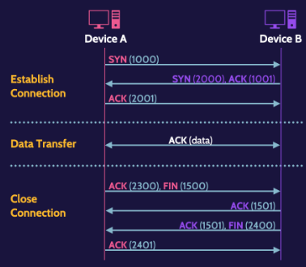

(Layer 4) Ports: Ports equate to services, and services are small applications that provide specific functionality. (ie: Port 80 = HTTP, which provides common web service)
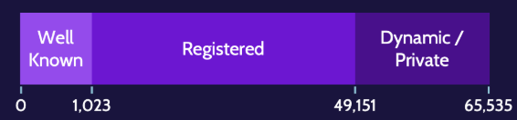
NOTE: Dynamic / Private = ‘Ephemeral Ports’ (Range of 49,151 - 65,535)
🚨Destination Certification CISSP TLDR 🚨

Layer 4: Transport: Manages end-to-end communication and data flow.
- TCP: Reliable, connection-oriented protocol with error checking.
- UDP: Unreliable, connectionless protocol; faster with no guarantees.
- SSL/TLS: Encrypts data for secure transmission; operates over TCP.
- Common Ports: 80=HTTP, 21=FTP, 23=Telnet, 443=HTTPS, etc.

Layer 5: Session: Establishes, manages, and terminates sessions between systems.
- PAP: Basic, insecure password authentication.
- CHAP: Secure challenge-response authentication.
- EAP: Flexible authentication framework.
- NetBIOS: Supports session-level communication in Windows networks.
- RPC: Executes functions on remote systems.
- SIP: Manages VoIP call setup and control.
- RTP: Delivers real-time audio and video.

- Circuit-Proxy Firewall: Monitors sessions and relays traffic after connection is established.
- Gateway: Translates between different protocols or architectures.

Layer 6: Presentation: Translates, encrypts, and compresses data for Layer 7 (App)
- Encryption: Secures data for confidentiality.
- Compression: Reduces data size for faster transmission.
- HTML: Markup language for displaying web content.
- ASCII: Standard text encoding format.
- Media Files / File Types (ie: JPEG, GIF, PDF, MP3, MP4, DOCX, etc.)

🚨Destination Certification CISSP TLDR 🚨

Layer 7: Application: Interfaces directly with user apps + handles high-level protocols.
Service | Description | Port(s)
HTTP | Web content (unencrypted) | 80
HTTPS | Web content (encrypted via SSL/TLS) | 443
FTP | File transfer (insecure) | 21 (control), 20 (data)
FTPS | FTP over SSL/TLS (secure) | 990 (implicit), 21 (explicit)
TFTP | Simple file transfer (no auth, no encryption) | 69 (UDP)
DNS | Resolves domains to IP addresses | 53 (TCP/UDP)
DNSSEC | Secures DNS using digital signatures | 53 (TCP/UDP) — same as DNS
Telnet | Remote access (plaintext, insecure) | 23
SSH | Encrypted remote access | 22
SMTP | Sends email | 25 (legacy), 465 (SSL), 587 (STARTTLS)
POP3 | Retrieves and deletes email from server | 110 (insecure), 995 (SSL)
SNMP | Network management and monitoring | 161 (queries), 162 (traps) — both UDP
IMAP | Retrieves email and keeps it on the server | 143 (insecure), 993 (SSL)

- Gateways: Translate protocols between different systems.
- Application Firewall: Filters traffic based on application-layer data. (Very Smart)

🚨Destination Certification CISSP TLDR 🚨

Convergence: Integration of voice, video, and data on one network.
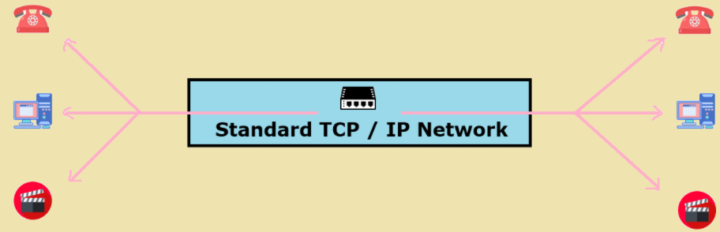

Converged Protocols: Protocols that carry multiple types of traffic over a single network.
- FCoE: Encapsulates Fibre Channel over Ethernet for storage. (No need for separate Fibre Channel cabling)
- iSCSI: Transmits SCSI commands over IP for networked storage. (Servers can access remote hard drives over LAN/WAN like local disks.)
- VoIP: Delivers voice calls over IP networks. (Zoom, Skype, Cisco phones)

PBX: Private phone system within an organization.
PSTN: Traditional public switched telephone network. (Old Landline Technology)
InfiniBand: High-speed interconnect for servers and storage. (Remote Direct Memory Access)
Compute Express Link (CXL): High-speed CPU-to-device interconnect for memory sharing. (Connects CPU to the other PC computer components like the RAM sticks)

VoIP-Specific Protocols:
- SRTP: Secure version of RTP; encrypts voice and video traffic.
- SIP: Manages setup, modification, and teardown of VoIP calls. (VoIP Session)

Network Attack Phases:
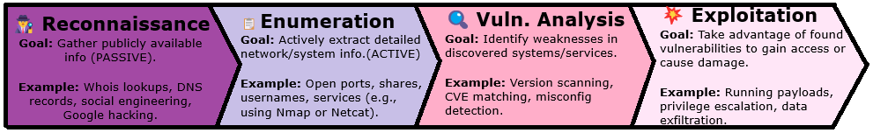

🚨Destination Certification CISSP TLDR 🚨

Passive Eavesdropping: Silently listens to network traffic.
Active Scanning: Sends probes to gather system information.
SYN Scanning: Sends SYN packets to identify open ports.
SYN Flooding: Overwhelms a system by sending many SYN requests.

MITM: Intercepts and possibly alters communication between parties.

Teardrop Attack: Sends malformed packets to crash systems.(Offensive Fuzzing)
Smurf: Sends spoofed ICMP to flood a target.
Fraggle: Sends spoofed UDP traffic to flood a target.

DNS Poisoning: Fakes DNS responses to redirect traffic.
ARP Poisoning: Sends false ARP messages to misroute traffic.

🔧Common Tools and Protocols:
Tool / Protocol | Description / Use Case
ping | Tests network connectivity using ICMP echo.
traceroute | Traces path packets take to a host.
ICMP | Sends network diagnostics and error messages.
DHCP | Assigns IP addresses automatically.
ipconfig | Displays and configures network settings.
whois | Retrieves domain registration info.
dig | Queries DNS records.
Putty | SSH/Telnet client for remote access.
Nmap | Scans networks for open ports and services.
John the Ripper | Cracks passwords using hashes.
Netstat | Shows active network connections.
nslookup | Looks up DNS records.

🚨Destination Certification CISSP TLDR 🚨

Wireless Technologies:
- WiFi: Wireless LAN using IEEE 802.11 standards.
- Bluetooth: Short-range wireless for device communication.
- Cellular: Mobile network for voice and data.
- RFID: Uses radio waves for identification and tracking.
- NFC: Very short-range wireless for secure transactions.

802.11 Wireless Protocol Family:
Type | Frequency | Top Speed
802.11 | 2.4GHz | 2 Mbps
802.11a | 5 GHz | 54 Mbps
802.11b | 2.4GHz | 11 Mbps
802.11g | 2.4GHz | 54 Mbps
802.11n | 2.4GHz & 5 GHz | 72 - 600Mbps
802.11ac | 5 GHz | 422 - 1300 Mbps(1.3Gbps)
802.11ax (WiFi 6) | 2.4GHz & 5 GHz | 10 Gbps

802.11 Security Solutions:
 | WEP | WPA | WPA2 | WPA3
Released | 1997 | 2003 | 2004 | 2018
Access Control | 802.1X | 802.1X or PSK | 802.1X or PSK | 802.1X or PSK
Authentication | EAP Methods | EAP Methods or PSK | EAP Methods or PSK | EAP Methods or PSK
Encryption | WEP | TKIP(RC4) | CCMP (AES Counter Mode) | CCMP or GCMP (Galois Counter Mode)
Integrity | None | Michael MIC | CCMP | CCMP or GCMP
WEP and WPA = WEAK
WPA2 = STRONG
WPA3 = STRONGEST

🚨Destination Certification CISSP TLDR 🚨

VLAN: Logically separates networks on the same physical switch. | SDN: Centralizes network control by separating the control and data planes.
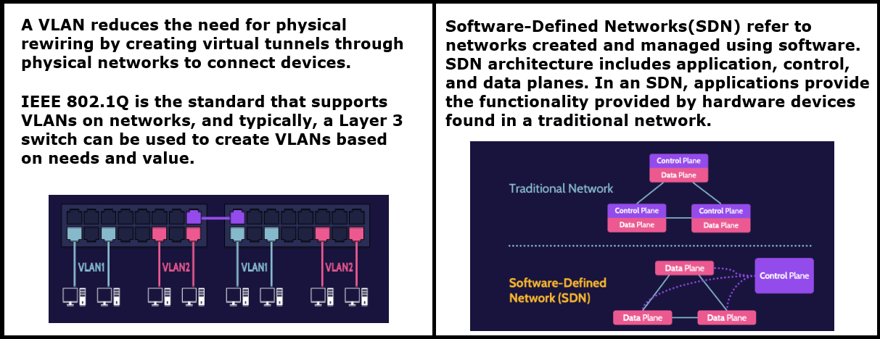

SDN Architecture: Communication between application and control planes is facilitated by northbound APIs; communication between data and control planes is facilitated by southbound APIs.
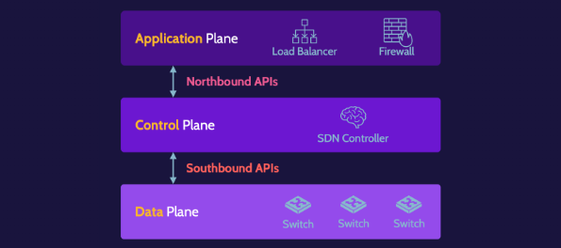

VPCs: Virtual private networks within a cloud that isolate resources logically.
- VPC = Logical Network separation for THE CLOUD
- VLAN = Logical Network separation for PHYSICAL NETWORK
IEEE 802.1Q: Standard for VLAN tagging in Ethernet frames.

🚨Destination Certification CISSP TLDR 🚨

Wide Area Network(WAN): Connects networks over large geographic areas.
- X.25: Early packet-switching WAN protocol; slow and outdated.
- Frame Relay: Faster than X.25; uses virtual circuits for WAN communication.
- ATM: Uses fixed-size cells for voice, video, and data over WAN.
- MPLS: Labels packets for efficient, flexible WAN routing.

Network Architecture:
- Defense in Depth: Multiple layers of security controls.
- Partitioning: Divides systems or networks to limit access.
Network Perimeter: Boundary between internal network and external networks.
- Network Segmentation: Splits network into zones to reduce risk and limit movement.
- Bastion Host: Hardened system exposed to the internet.
- DMZ: A network zone that separates public-facing services from the internal network for added security.
- Microsegmentation: Granular isolation of workloads within a network.
- Clustering: Grouping systems for load balancing or redundancy.

Proxy: Acts as an intermediary between clients and external servers.
NAT: Translates private IP addresses to a public one.
PAT: NAT that maps multiple private IPs to one public IP using ports.

Firewall Technologies:
Firewall Type | OSI Layer | Function / Use Case
Packet Filtering  (FAST and DUMB) | Network(3) | Allows or blocks traffic based on IP, port, or protocol.  (Examines Packet Headers and Allows/Blocks based on ACL)
Stateful Packet Filtering | Network(3) | Tracks active connections and filters traffic based on state.  (Connection state is stored and dynamically updated)
Circuit-Level Proxy | Session(5) | Monitors TCP handshakes without inspecting content.  (Creates a Circuit(channel) without requiring service knowledge)
Application-Level  (SLOW and SMART) | Application(7) | Inspects and filters traffic at the application layer.  (Can inspect packet payload; Different proxy needed per service)
🚨Destination Certification CISSP TLDR 🚨

Firewall Architectures:
- Packet Filtering: Basic firewall filtering based on headers (IP, port, protocol).

- Dual-Homed Host: One system with two NICs separate networks.

- Screened Host: Firewall + bastion host in front of internal network.

- Screened Subnet: DMZ between two firewalls isolating internal and external traffic.

- Three-Legged Firewall: Firewall with three interfaces (internal, external, DMZ).

Mirror/Span/Promiscuous Port Settings: Network Switch Port Settings
- Mirror: Copies traffic from one port to another for monitoring.
- Span: Cisco’s term for port Mirroring. (Same as Mirroring)
- Promiscuous: Network interface captures all traffic, not just its own.

Error Type | Statistical Term | Biometric Term | Also Known As
Type 1 Error | “False Positive” | False Rejection Rate (FRR) | Legit user rejected
Type 2 Error | “False Negative” | False Acceptance Rate (FAR) | Unauthorized user accepted
NOTE: Type 2 Errors(False Negatives or FAR) are MUCH WORSE than a Type 1 Error!

Enticement: Legal activity of persuading someone to commit a crime that they were ALREADY planning on commiting anyways (ie: Honeypot / Honeynet)

Entrapment: Illegal activity of persuading someone to commit a crime that they would not otherwise have committed / WERE NOT planning to commit (ie: Blackmailing)

🚨Destination Certification CISSP TLDR 🚨

Tunneling & VPNs: (TUNNELING + ENCRYPTION = VPN)
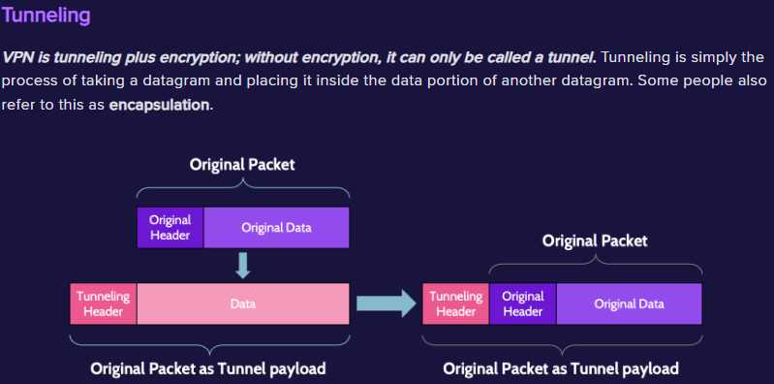
VPN: Encrypted tunnel over untrusted networks.
Split Tunneling: Routes only some traffic through the VPN.
GRE: Tunnels arbitrary network layer protocols over IP.
SOCKS:
SOCKS: Proxy protocol that handles any traffic type at Layer 5.

Tunneling and VPN Protocols:
Protocol | Tunneling? | Encryption? | OSI Layer
SSH - Secure Shell | ✔️ | ✔️ | 7 - Application
SOCKS - Socket Secure | ✔️ | ✔️ | 5 - Session
SSL/TLS - Secure Sockets Layer / Transport Layer Security | ✔️ | ✔️ | 4 - Transport
IPSec - Internet Protocol Security | ✔️ | ✔️ | 3 - Network
GRE - Generic Routing Protocol | ✔️ |  | Encapsulation at multiple layers  2 - Data Link
L2TP - Layer 2 Tunneling Protocol | ✔️ |  | Encapsulation at multiple layers  2 - Data Link
L2F - Layer 2 Forwarding Protocol | ✔️ | ✔️ | Encapsulation at multiple layers  2 - Data Link
PPTP - Point-to-Point Tunneling Protocol | ✔️ | ✔️ | Encapsulation at multiple layers  2 - Data Link
🚨Destination Certification CISSP TLDR 🚨

IPSec: Encrypts and authenticates IP traffic at Layer 3 using AH and ESP and Operates in either Transport Mode OR Tunnel Mode

IPSec Modes:
Authentication Header (AH) | Encapsulating Security Payload (ESP)
Provides Integrity, Data-Origin Authentication, and Replay Protection | Provides Integrity, Data-Origin Authentication, Replay Protection, and Confidentiality through Encryption of the Payload

Transport Mode | Tunnel Mode
Use header of original packet, followed by the AH or ESP header, then the payload itself | New header encapsulates the AH or ESP header and the original IP header and payload

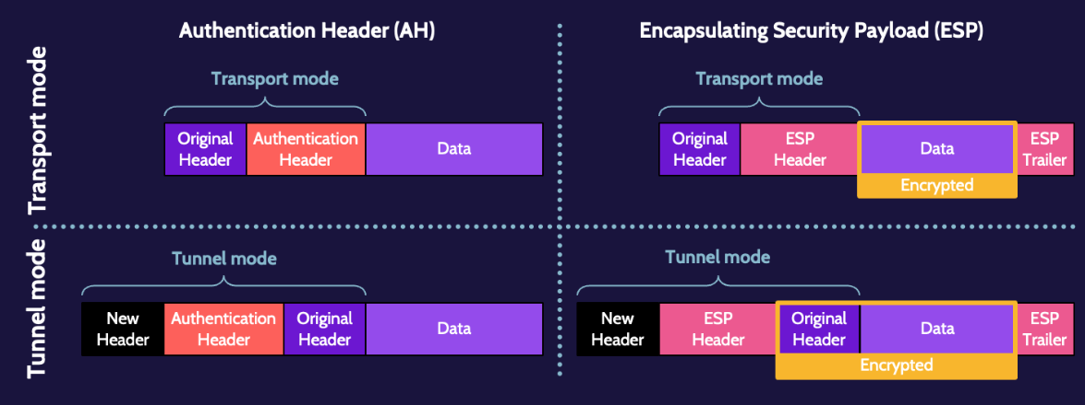

Internet Key Exchange (IKE): Negotiates keys and settings for IPSec.

Security Association (SA): Agreed settings and keys between IPSec peers.

SSL/TLS for VPNs: Uses HTTPS to create encrypted VPN tunnels (Layer 4/7).

🚨Destination Certification CISSP TLDR 🚨

TLS VPN vs IPSec VPN:
TLS VPN | IPSec VPN
🔹Operates at the Transport Layer(4) and above  🔹Can be used to encrypt traffic sent between ANY Processes identified by port numbers  🔹Encrypts connections by default  🔹Easier to Establish / More granular control  🔹A successful attack could lead to compromise of specific systems and applications  (Works over HTTPS (Layer 4/7), easier to traverse firewalls, ideal for remote access.) | 🔹Operates at ONLY Network Layer(3)  🔹Can be used to encrypt traffic between ANY System that can be identified by an IP Address  🔹The use of IKE provides a layer of data Authentication via an external protocol  🔹Does NOT Encrypt connections by default  🔹Can be more complicated to establish, configure, and manage  🔹A successful attack could lead to compromise of the ENTIRE network  (Operates at Layer 3, secures ALL IP traffic, better for site-to-site tunnels.)
RADIUS: Centralized AAA protocol; combines authentication and authorization, uses UDP.
TACACS+: Cisco AAA protocol; separates authentication, authorization, and accounting, uses TCP.
Diameter: Successor to RADIUS; more secure and scalable, uses TCP/SCTP.

Access control enables management to:
- Specify which users can access the system → Identification & Authentication
- Specify what resources they can access → Authorization
- Specify what operations they can perform → Access Control / Authorization
- Provide individual accountability—know who is doing what → Accountability (via Auditing & Logging)
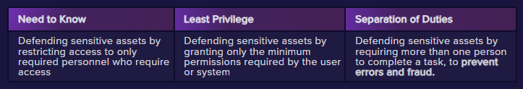

Groups | Roles
Collections of users with shared permissions. | Defined sets of permissions assigned based on job function.
🚨Destination Certification CISSP TLDR 🚨

Access Control Administration Approaches:
- Centralized: One authority manages all access controls.
- Decentralized: Access control managed by individual departments or systems.
- Hybrid: Combines centralized oversight with local control. (Legacy Systems)

Access Control Services(which includes AAA Services):
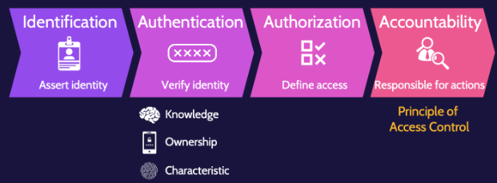

Authentication Types: “Know, Have, Are”
Type 1 Authentication: Something you KNOW (e.g., password, PIN).
Type 2 Authentication: Something you HAVE (e.g., smart card, token).
Type 3 Authentication: Something you ARE (e.g., fingerprint, iris).

One-Time Passwords:
- Synchronous: OTP generated using time or counters. (Common)
- Asynchronous: OTP generated in response to a challenge.(LESS Common)

Smart Card: Contains a microprocessor for secure authentication. (DoD CAC Card)
Memory Card: Stores data only; no processing capabilities. (Magnetic Stripe)

Type 1 Error | FRR (False Rejection Rate): Legitimate users incorrectly denied access.
Type 2 Error | FAR (False Acceptance Rate): Unauthorized users incorrectly granted access. (VERY VERY BAD)
CER (Crossover Error Rate): Point where FAR and FRR are equal; measures biometric accuracy.

🚨Destination Certification CISSP TLDR 🚨

Credential Management System: Securely stores, manages, and issues user authentication credentials.

Single Sign On (SSO) | Federated Identity Management (FIM)
🔑 SSO = One login, many apps (same org).  Identity Source: Centralized identity provider  A user logs in once and gains access to multiple systems within one organization. | 🤝 FIM = One identity, many domains (trusted orgs).  Identity Source: Federated identity providers  A trust relationship that allows a user to access systems across different organizations using one identity.
Related Ideas:  Kerberos, SAML, OAuth(within org)  SESAME | Related Ideas:  SAML, OpenID Connect, OAuth(between orgs)  WS-Federation

OAuth | OpenID
(AUTHORIZATION)  🛂 OAuth = Access control (authorize app to use your data)  Goal: Grant access to data | (AUTHENTICATION)  🧑‍💼 OpenID = Identity verification (log in with Google/Facebook/etc)  Goal: Verify user identity

Kerberos: Ticket-based authentication using secret-key cryptography.
CAPTCHA: Test to block bots by verifying human users.
Password Vaults: Securely store and manage user passwords.
Session Management: Tracks and controls user sessions after login.
Registration (Identity Proofing): Verifies identity before granting credentials.

Authenticator Assurance Levels(AAL):
AAL1 | Authentication: Single-factor required (e.g., password only).  Security: Minimal; vulnerable to phishing or weak credentials. | LOW ASSURANCE
AAL2 | Authentication: Multi-factor authentication (MFA) required.  Methods: Combination of something you know (password) + something you have (OTP token, phone, etc.). | MODERATE ASSURANCE
AAL3 | Authentication: Hardware-based MFA with proof of possession + resistance to impersonation.  Methods: Cryptographic tokens (e.g., smart cards, FIDO2) + verifier impersonation resistance. | HIGH ASSURANCE
🚨Destination Certification CISSP TLDR 🚨

Federation Components:
Principal/User: The person or entity requesting access.
Identity Provider (IdP): Authenticates the user and provides identity information.
Service Provider (Relying Party): Provides services and trusts the IdP’s authentication.
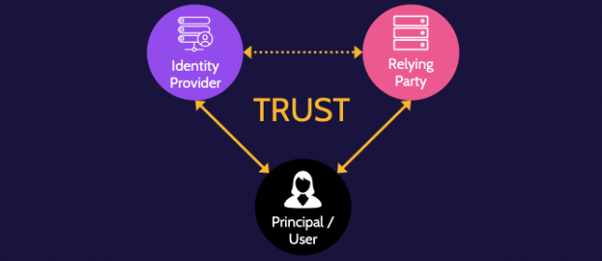

SAML: XML-based SSO for exchanging authentication and authorization data.
WS-Federation: SSO protocol using web services standards.(SAML for web services)
OpenID: Authenticates users using a third-party IdP.
OAuth: Grants limited access to resources without sharing credentials.
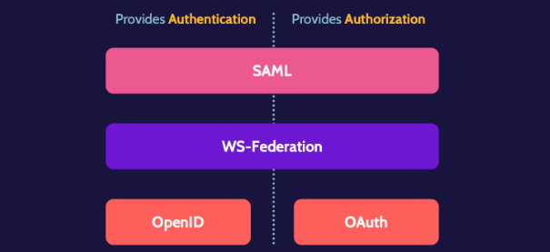

🚨Destination Certification CISSP TLDR 🚨

SAML Process:
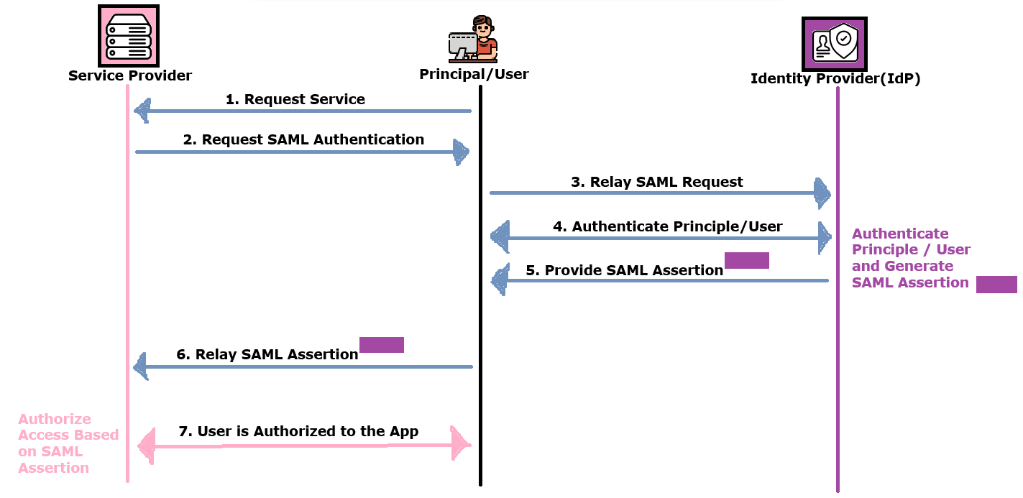
SAML Major Components:
- Assertion: Statement from IdP about a user's identity and access.
- Protocol: Defines how SAML requests and responses are structured.
- Bindings: Maps SAML messages to transport protocols (e.g., HTTP).
Profiles: Use-case definitions combining assertions, protocols, and bindings.

⭐ACCOUNTABILITY = PRINCIPLE OF ACCESS CONTROL
In order to achieve Accountability…
- Users must be uniquely Identified
- Users must be properly Authenticated
- User must be properly Authorized
- All Actions must be properly Logged

AAA Services at its CORE:
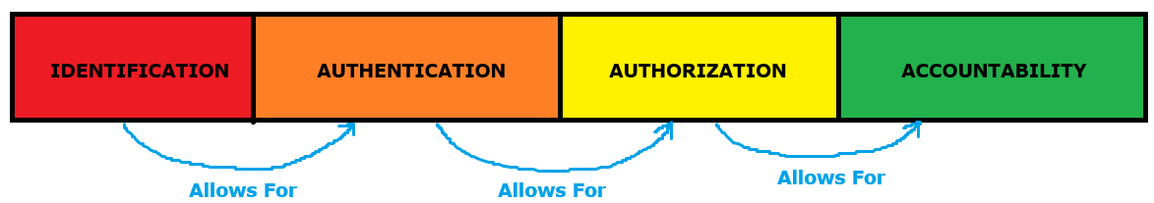

🚨Destination Certification CISSP TLDR 🚨

Cloud Identity: User account created and managed entirely in the cloud.
Synced Identity: On-prem account synced with cloud but managed locally.
Linked Identity: Separate on-prem and cloud accounts linked by tools like SSO.
Federated Identity: Trust-based authentication across different organizations or domains.

IDaaS:Cloud-based identity and access management (IAM) service by Third Party
🔐 Key Features | ☁️ Benefits:
🔹SSO (Single Sign-On)  🔹MFA (Multi-Factor Authentication)  🔹User provisioning/deprovisioning  🔹Directory services  🔹Federated identity management  🔹Available On-Prem AND in the Cloud | 🔹Centralized identity management in the cloud  🔹Reduces internal infrastructure burden  🔹Enables secure access across on-prem and cloud apps  🔹Supports mobile and remote workforces

IDaaS Risks:
- Availability of the Service
- Protection of Critical Identity Data
- Entrusting Third Party with Sensitive or Proprietary Data

Discretionary Access Control (DAC): Owner controls access to their resources.
Role-Based Access Control (RBAC): Access based on user roles.
Attribute-Based Access Control (ABAC): Access based on user, resource, and environment attributes.
Mandatory Access Control (MAC): Access enforced by system, based on classification levels. (LABELS)
Rule-Based Access Control: Access based on predefined rules or conditions.
Risk-Based Access Control: Grants access based on risk level or context.

Reference Monitor Concept(RMC): Enforces access control between subjects and objects with completeness, isolation, and verifiability. (Used in MAC)

Policy Enforcement Point (PEP): Enforces access (BLOCK/ALLOW Access)

Policy Decision Point (PDP): Evaluates access requests and makes decisions.

Policy Engine: Processes rules and policies to support PDP decisions.
🚨Destination Certification CISSP TLDR 🚨

Identity Life Cycle:

- Provisioning: upon hire of a new employee and when an employee changes roles. Provisioning activities include background checks, confirming skills, and identity proofing, among other things.
- Review (also known as user access review): should take place as often as necessary and more frequently for higher privilege accounts. Assets and systems to which a user has access should be reviewed by the asset or system owner to determine if ongoing access is necessary or if access should be modified.
- Revocation: upon voluntary or involuntary termination. It typically takes place when an employee leaves the organization, through voluntary or involuntary separation, but it can also take place when an employee changes roles.

User Access Review: Periodic check to ensure users have appropriate access.
Privilege Escalation: Gaining higher access levels, often via tools like sudo; must be monitored and audited. (Check ‘sudoers’ file’)
Service Account Management: Controls and audits non-human accounts used by applications or services. (Service Account = Account used to RUN Applications)

Validation | Verification
✅ Validation = Expectation  Ensures the right product was built (meets user needs)  "Did we build the right product?"  User acceptance testing, system testing | ✅ Verification = Specification  Ensures the product was built correctly (meets specifications)  "Did we build the product right?"  Code review, unit testing, static analysis

Terms Associated with VERIFICATION (Specification):
- Completeness: All required elements are present.
- Correctness: Elements function as intended.
- Consistency: Elements do not conflict and behave predictably.

🚨ASSURANCE IS PROVIDED THROUGH VALIDATION AND VERIFICATION

🚨Destination Certification CISSP TLDR 🚨

Types of Tests:
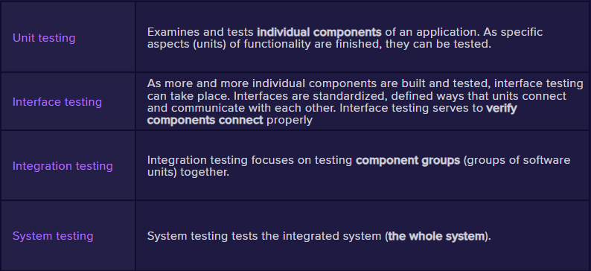

High Level Overview of Required Software Testing:
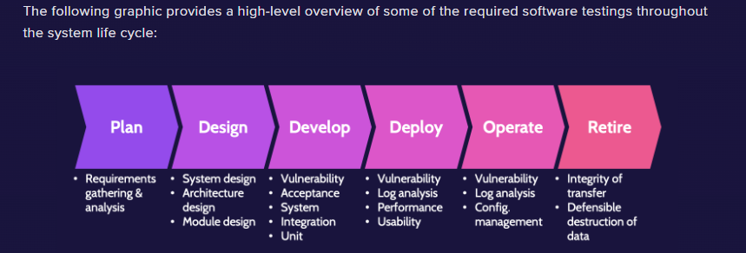

SAST: Scans source code for vulnerabilities without executing it. (White Box)
DAST: Tests running applications for security flaws from the outside. (Black Box)
Fuzz Testing: Sends random or malformed input to find bugs. (A form of DAST)
Mutation Fuzzers: Alter known inputs to create test cases.
Generational Fuzzers: Create inputs based on models of valid data.

🚨Destination Certification CISSP TLDR 🚨

Equivalence Partitioning: Divides input data into valid and invalid groups for testing.
Boundary Value Analysis: Tests values at the edges of input ranges.
Decision Table Analysis: Uses tables to model complex business rules and conditions. (Useful for complex software testing and requirements management)
State-Based Analysis: Tests application behavior based on different states and transitions. (Useful for testing GUIs and communication protocols)

Vulnerability Assessment VS Penetration Testing:
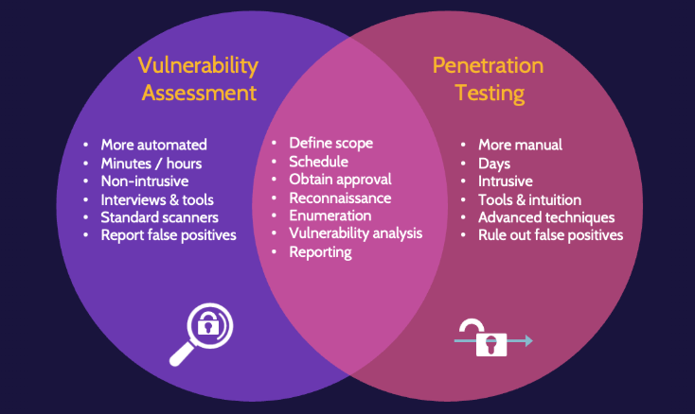

Vulnerability Assessment / Penetration Testing Phases:
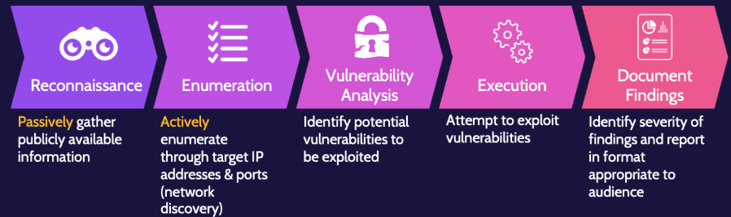
NOTE: ONLY PENTESTING WILL CONDUCT STEP 4: EXECUTION / EXPLOITATION
🚨Destination Certification CISSP TLDR 🚨

Blind Testing: Tester has no prior knowledge of the target.
Double Blind Testing: Neither Tester nor the target staff knows the test is happening.

Vulnerability Management Process:
1) Asset Inventory
2) Asset Valuation
- Data/Asset Classification and Categorization Structure
- Identified Owner for each Asset (Ultimate Accountability)
- Each Asset is assigned a Classification and Category
3) Identifying the Vulnerabilities for each Asset as well as Recovery/Remediation
4) Ongoing Review and Assessment (Continuous Monitoring)

CVE: Public identifier for a known security vulnerability. (CVE 2025-12345)
CVSS: Standard scoring system to rate vulnerability severity. (1-10 “10=BAD”)
False Positive: Alert triggered when no issue exists.
False Negative: Missed detection of a real issue.

Logging and Monitoring Process:
- Generation: Create logs from systems and devices.
- Transmission: Send logs to a central location.
- Collection: Gather logs from various sources.
- Normalization: Format logs into a standard structure.
- Analysis: Examine logs for patterns, anomalies, or threats.
- Retention: Store logs for compliance or future review.
- Disposal: Securely delete logs when no longer needed.

Limiting Log Sizes:
- Circular Overwrite: Reuses oldest log data when storage is full.
- Clipping Levels: Ignores normal events and alerts only on defined thresholds.

Real User Monitoring (RUM): Tracks actual user interactions in real time.

Synthetic Performance Monitoring: Simulates user actions to test performance proactively.

🚨Destination Certification CISSP TLDR 🚨

Security Process Data(Metrics)
🔸KPIs and KRIs help inform goal setting, action planning, performance, and review
KPIs (Key Performance Indicators): Metrics that measure success against goals. (KPIs = Backwards Looking)
KRIs (Key Risk Indicators): Metrics that signal potential risks. (KRIs = Forwards Looking)
SMART: Goal-setting criteria—Specific, Measurable, Achievable, Relevant, Time-bound.

Test Output:
Remediation: Fixes or mitigates identified vulnerabilities.
Exception Handling: Manages deviations from policy with documented approval.
Ethical Disclosure: Responsibly reports vulnerabilities to affected parties.

💲SOC 1: Reports on internal controls over financial reporting.
- Type 1: Describes controls at a point in time. (Just Design)
- Type 2: Tests controls over a period of time. (Design as well as Operating Effectiveness of the Controls)
🔐SOC 2: Reports on controls related to security, availability, processing integrity, confidentiality, and privacy.
- Type 1: Evaluates design of controls at a point in time.(Just Design)
- Type 2: Evaluates effectiveness of controls over time. (Design as well as Operating Effectiveness of the Controls)
📢SOC 3: Public summary of a SOC 2 report, with no detailed findings.

Executive (Senior) Management: Sets strategy and approves security policies.
Audit Committee: Oversees audit functions and financial reporting integrity.
Security Officer: Advise on security related risks to be evaluated in Audit
Compliance Manager: Ensures adherence to laws, regulations, and policies.
Internal Auditors: Evaluate internal controls and report to management.
External Auditors: Independently assess compliance and financial accuracy.

🚨Destination Certification CISSP TLDR 🚨

Securing the Scene: Preserve evidence and prevent contamination.
Chain of Custody: Documented trail of evidence handling.
MOM: “Motive, Opportunity, and Means”
- Motive: Reason the suspect would commit the act.
- Opportunity: Chance or access to commit the act.
- Means: Ability or tools to carry out the act.

Forensic Investigation Process:
1. Identification: Recognize potential evidence and incident scope.
2. Preservation: Protect evidence from alteration or damage.
3. Collection: Gather evidence using proper procedures.
4. Examination: Extract relevant data from evidence.
5. Analysis: Interpret data to understand what happened.
6. Presentation: Report findings clearly and accurately.
7. Decision/Documentation: Use findings to support legal or organizational action.

Real Evidence: Physical objects directly involved in the incident.
Direct Evidence: Proves a fact without inference (e.g., eyewitness testimony).
Circumstantial Evidence: Implies a fact through related details.
Corroborative Evidence: Supports or confirms other evidence.
Hearsay Evidence: Secondhand testimony; generally inadmissible in court.
Best Evidence Rule: Original documents must be used when available.
Secondary Evidence: Copies or summaries used when originals aren’t available.

Criminal Law: Laws that define offenses against society and prescribe punishments by the state.
Civil Law: Governs disputes between individuals or entities over rights, obligations, and liabilities.
Regulatory Law: Rules issued by government agencies to enforce statutes and ensure compliance.
Administrative Law: Governs the actions and procedures of government agencies and public officials.
Organizational Law: Internal rules and policies that govern employee behavior within an organization.

⚖️ "Beyond a Reasonable Doubt" - Legal Standard of Proof for Criminal Law
⚖️ "Preponderance of the Evidence" - Legal Standard of Proof for Civil Law

🚨Destination Certification CISSP TLDR 🚨

Locard's Exchange Principle: Every contact leaves a trace—evidence is always transferred.
Live Evidence: Data from a running system (e.g., RAM, active network connections).
Forensic Copies (Bit-for-Bit): Exact duplicate of storage, preserving all data and structure.
Artifacts: Residual data showing user activity (e.g., logs, registry entries, browser history).

5 Rules of Evidence:
Authentic: Proven to be what it claims to be. (Not Fabricated or Planted)
Accurate: Correct and free from tampering. (Has Integrity)
Complete: All relevant evidence is included. (All parts presented)
Convincing/Reliable: Trusted and credible to support findings.(High Degree of Truth; Technical Findings must be translated properly for Non-Technical people ie: Judge/Jury)
Admissible: Legally acceptable in court. (Chain of Custody helps, but no Guarantee!)

SIEM:
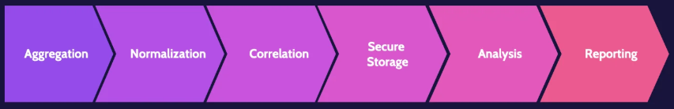
Aggregation: Collecting log data from multiple sources.
Normalization: Converting data into a consistent format.
Correlation: Linking events across systems to detect patterns.
Secure Storage: Protecting logs from unauthorized access or tampering.
Analysis: Reviewing data to identify threats or anomalies.
Reporting: Presenting findings to stakeholders or responders.

Threat Intelligence: Information about threats to help prevent or respond to attacks. (Includes Threat Identification, Research, and Analysis)
UEBA (User and Entity Behavior Analytics): Detects anomalies by monitoring behavior patterns.
EDR (Endpoint Detection and Response): Monitors and responds to threats on endpoint devices.

🚨Destination Certification CISSP TLDR 🚨

Continuous Monitoring: Ongoing assessment of systems to detect security threats and changes in real time. (Most likely conducted by the SIEM)
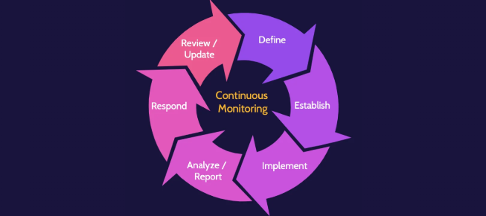
Continuous Monitoring Steps(CYCLICAL):
- Define: Identify goals, scope, and requirements.
- Establish: Set up policies, procedures, and tools.
- Implement: Deploy controls and begin operations.
- Analyze/Report: Monitor performance and generate findings.
- Respond: Take action based on analysis or incidents.
- Review/Update: Evaluate and improve processes regularly.

SOAR (Security Orchestration, Automation, and Response): Platform that automates security operations, coordinates tools, and manages incident response.
3 Main Focus Areas of SOAR:
- Threat and Vulnerability Management
- Incident Response
- Security Operations Automation

Configuration Management: Maintains system integrity through control of changes.
- Provisioning: Setting up systems and resources for use.
- Baselining: Establishing a known-good configuration.
- Automation: Using tools to apply and enforce configurations consistently.

🚨Destination Certification CISSP TLDR 🚨

Asset Inventory: Complete list of hardware, software, and data owned and used by an organization.

Asset Management Life Cycle (Cyclical):
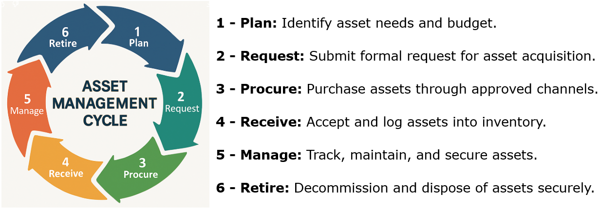

Media Types:
- Paper
- Microforms (microfilm, microfiche)
- Magnetic (HDDs, Disks, Tapes)
- Flash Memory (SSD and Memory Cards)
- Optical (CDs and DVDs)

Hardware and Software Asset Management Essentials:
- Asset Management Life Cycle

- Inventories

- Patching

- Software Licensing

- Secure Configuration

🚨Destination Certification CISSP TLDR 🚨

Incident Management: Overall process for detecting, handling, and resolving incidents.
Incident Response: Specific actions taken to contain, investigate, and recover from an incident. (Falls under Incident Management)
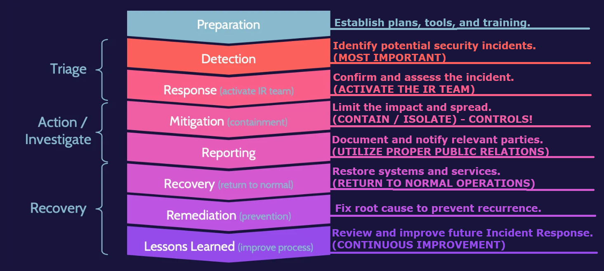

Event: An observable occurrence
Incident: An adverse event (Successful or Not)
- A successful hack and a hacking attempt are BOTH Incidents

Anti-Malware: Detects and removes malicious software.
- Signature-Based: Matches known malware patterns.
  - Update Signatures Regularly!
  - UNABLE to Detect Zero-Day Malware

- Heuristic (Anomaly): Detects unknown threats based on behavior or code analysis.
  - Has the ability to Sandbox potential malware files for analysis using:
    - Static Testing (White Box)
    - Dynamic Testing (Black Box)

Activity Monitors: Track system or user behavior for suspicious actions.
Change Detection: Alerts on unauthorized or unexpected modifications to systems or files.

🚨Destination Certification CISSP TLDR 🚨

Malware Name | Description
Virus | Attaches to files and spreads when executed.
Worm | Self-replicates and spreads across networks without user action.
Companion | Hides by naming itself like a legitimate file.
Macro | Embedded in documents and runs via office software.
Multipartite | Spreads in multiple ways (e.g., file + boot sector).
Polymorphic | Changes code to avoid detection.
Trojan | Disguised as legitimate software; performs hidden malicious actions.
Botnet | Network of compromised devices controlled remotely.
Boot Sector | Infects the boot sector of storage media.
Hoax / Prank | False alerts or misleading messages causing user disruption.
Logic Bomb | Malicious code triggered by specific conditions.
Stealth | Hides itself from detection tools.
Ransomware | Encrypts data and demands payment for access.
Rootkit | Hides malware and gives the attacker root access.
Data Diddler | Subtly alters data for long-term manipulation.
Salami Attack | Steals small amounts of money over time to avoid detection.
ZERO-DAY | Exploits a vulnerability not yet known by the developers or able to be patched

Machine Learning (ML): Enables systems to learn from data and improve over time.
Artificial Intelligence (AI): Simulates human intelligence in machines.
Deep Learning: ML using neural networks with many layers for complex tasks.
Supervised Learning: Trains models on labeled data.
Unsupervised Learning: Finds patterns in unlabeled data.
🚨Destination Certification CISSP TLDR 🚨

Patch Management: helps create a secure environment by fixing—patching—security flaws and vulnerabilities in systems. Patching only secures a system against known vulnerabilities.
Once the need for an available patch has been identified, change management process should be employed as part of the decision to move forward and install the patch.
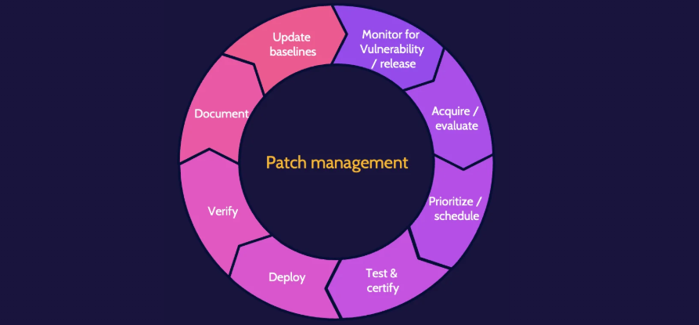
1. Monitor for Vulnerability and Baselines: Identify missing patches and compare against secure configurations.
2. Acquire / Evaluate: Obtain patches and assess relevance and risk.
3. Prioritize / Schedule: Rank patches by urgency and plan deployment.
4. Test and Certify: Validate patches in a controlled environment.
5. Deploy: Apply patches to production systems.
6. Verify: Confirm patches were applied successfully.
7. Document: Record patch details, changes, and outcomes.
8. Update Baselines for Configurations: Adjust secure config standards to reflect new patches.

Methods for Determining Patch Levels:
- Agent: Installed software on endpoints collects and reports patch status.
- Agentless: Uses remote scans or protocols (e.g., SSH, WMI) without installing software.
- Passive: Observes network traffic to infer patch levels without active scanning.

🚨Destination Certification CISSP TLDR 🚨

Deploying Patches:
- Manual: Admins apply patches by hand on each system. (for Critical Systems)
- Automated: Patching software automatically propagates the eligible systems

Change Management:
- Change Request: A change request can come from any part of an organization and pertain to almost any topic. Organizations typically use some type of change management software.
- Assess Impact: After a change request is made, however small the request might be, the impact of the potential change must be assessed.
- Approval: Based on the requested change and related impact assessment, common sense plays a big part in the approval process.
- Build and Test: After approval, any change should be developed and tested, ideally in a test environment.
- Notification: Prior to implementing any change, key stakeholders should be notified.
- Implement: After testing and notification of stakeholders, the change should be implemented.
- Validation: Once implemented, senior management and stakeholders should again be notified to validate the change.
- Version and baseline: Documentation should take place at each step noted. Still, at this point, it's critical to ensure all documentation is complete and to identify the version and baseline related to a given change.
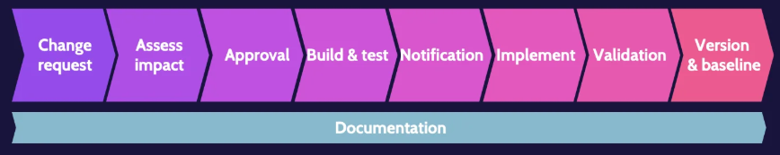

Fail Open (Fail Soft): System allows access if security controls fail.
Fail Closed (Fail Secure): System denies access if security controls fail.
-Not Related to the above terms-
Fail Safe: System defaults to the safest condition to protect people and assets.

🚨Destination Certification CISSP TLDR 🚨

Archive Bit is technical detail—metadata—that indicates the status of a backup relative to a given backup strategy.
- 0 = no changes to the file or no backup required
- 1 = file has been modified or backup required.

Incremental Backup: Backs up only data changed since the last backup of any type.
Differential Backup: Backs up data changed since the last full backup.
Full Backup: Copies all selected data every time.
Mirror Backup: Exact real-time copy of source data without version history.

Offsite Storage: Stores backup data at a separate physical location.
Tape Rotation: Uses a scheduled cycle of backup tapes to manage retention.
Electronic Vaulting: Transfers backup data electronically to a secure remote site.

Cyclic Redundancy Check (CRC): Error-detecting code used to check data integrity during storage or transmission.

RAID Levels, Performance, and Minimum Drives:
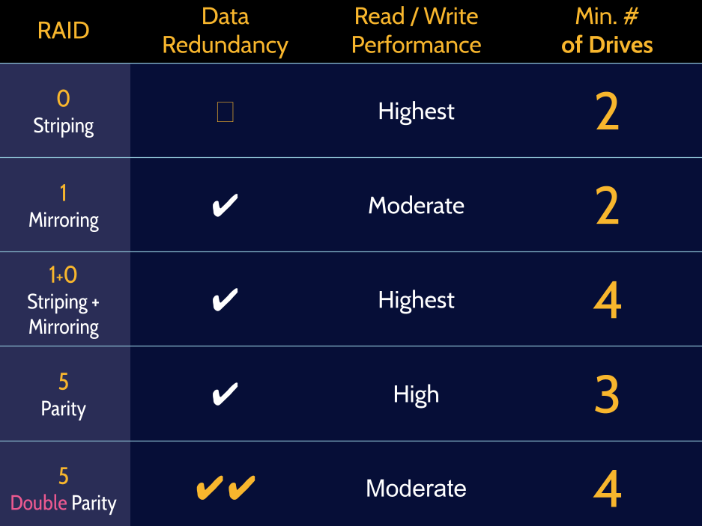
🚨Destination Certification CISSP TLDR 🚨

Business Impact Analysis (BIA) is the process that helps an organization identify its most critical functions, services, assets, systems, and processes. RPO and RTO are subsequently determined to understand how much data and how quickly these systems and processes need to be recovered. (See next page for steps)
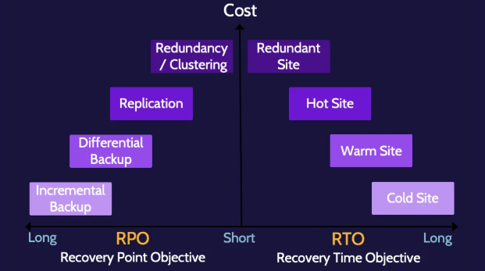

The key BCP/DRP steps are:
- Develop contingency planning policy
- Conduct BIA
- Identify controls
- Create contingency strategies
- Develop contingency plan
- Ensure testing, training, and exercises
- Maintenance
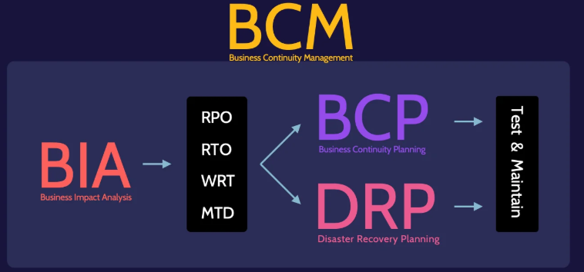
🚨Destination Certification CISSP TLDR 🚨

Clustering: Multiple systems to work as one for high availability. (Multiple Systems)
Redundancy: Duplication of critical components to prevent failure. (Single System)
RAID: Combines multiple disks for performance, redundancy, or both. (Drive Level)

RPO (Recovery Point Objective): Maximum acceptable data loss in time.
RTO (Recovery Time Objective): Maximum acceptable downtime.
WRT (Work Recovery Time): Time needed to restore business operations after systems are up.
MTD (Maximum Tolerable Downtime): Longest time a system can be down before serious impact. (Business Failure / Disaster Recovery Plan(DRP) is Invoked)
MTBF (Mean Time Between Failures): Average time between equipment failures.
MTTF (Mean Time To Failure): Average time until a non-repairable system fails.

⭐If RTO > MTD the DRP is Invoked / Activated (Business Disaster)

BIA includes:
- Determine mission/business processes and recovery criticality
- Identify resource requirements
- Identify recovery priorities for system resources

Reciprocal Agreements: Two organizations agree to support each other during disasters.
Resource Capacity Agreements: Ensure access to needed resources (e.g., hardware, bandwidth) during emergencies.

Business Continuity Management (BCM)
The Business function and processes that provide the structure, policies, procedures, and systems to enable the creation and maintenance of BCP and DRP plans.

Business Continuity Planning (BCP) | Disaster Recovery Plan (DRP)
(STRATEGIC in Nature)  Focuses on survival of the business and the capability for an effective response. | (TACTICAL in Nature)  Focuses on the recovery of vital technology infrastructure and systems.

🚨Destination Certification CISSP TLDR 🚨

Restoration Order: Sequence in which systems and services are brought back online. (Most Critical / Valuable / or Essential Systems FIRST)
Dependency Charts: Visual maps showing relationships and dependencies between systems (to aid in proper restoration order establishment).

DRP Elements:
When restoring systems/operations at the Primary Site: Restore the least critical first
When restoring systems/operations at the Recovery Site: Restore the MOST critical first

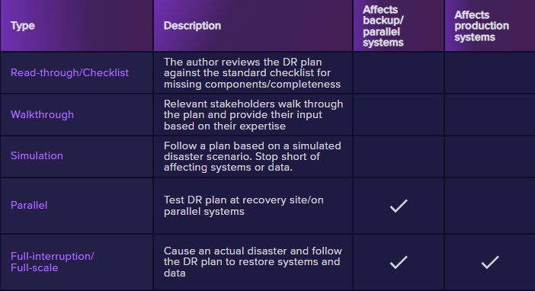

3 Goals of BCM:
1) Safety of People (MOST IMPORTANT)

2) Minimization of Damage (MODERATE)

3) Survival of the Business(IMPORTANT)

🚨Destination Certification CISSP TLDR 🚨
SLC (System Life Cycle): Overall lifespan of an IT system from planning to disposal.
SDLC (Software Development Life Cycle): Structured process for developing, testing, and deploying software.
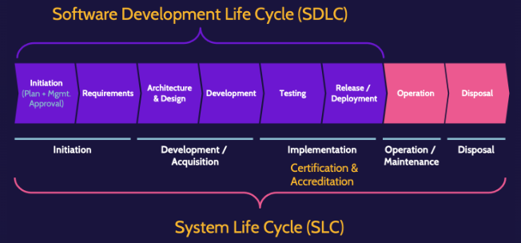

Development and Maintenance Life Cycle: Covers planning, designing, coding, testing, deploying, and maintaining systems or software throughout their operational life.
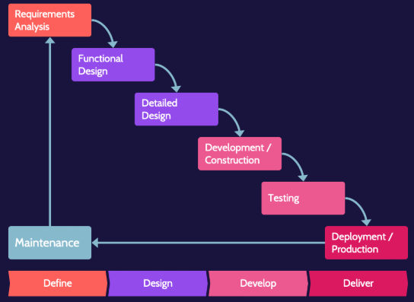
🚨Destination Certification CISSP TLDR 🚨

Development Methodologies:
- Waterfall: Linear, step-by-step development process.
- Structured Programming Development: Emphasizes top-down design and modular code.
- Agile: Iterative development with frequent feedback and flexibility.
- SAFe (Scaled Agile Framework): Applies Agile at enterprise scale with structured roles and planning.
- Spiral: Combines iterative development with risk analysis at each cycle.
- Cleanroom: Focuses on defect prevention with formal methods and extensive testing.

Agile Scrum Master: Facilitates the Scrum process, removes team obstacles, and ensures Agile practices are followed. (No Formal Authority; Communicates for Management and the Team as a ‘Middleman’)

Maturity Models:
- Capability Maturity Model (CMM): Rates process maturity from initial to optimized. (Helps drive business performance)
- Software Assurance Maturity Model (SAMM): Guides secure software development practices.(Analyze and Improve Software Security Posture)
- Risk Maturity Model (RMM): Measures an organization's risk management capability maturity. (Measureable Capability to Handle a Risk in an organization)

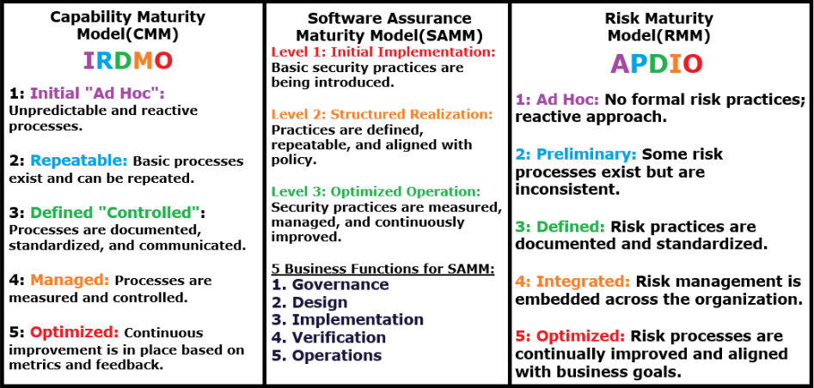
🚨Destination Certification CISSP TLDR 🚨

Integrated Product Team (IPT): Cross-functional group that collaborates throughout a system’s life cycle to ensure quality, cost, and performance objectives are met. (Older version of DevOps essentially, created by the DoD in the late 1990s)

DevOps: Combines development, operations, and Quality Assurance to speed up software delivery through collaboration and automation. (Enables CI/CD, which can facilitate 100s of deployments PER DAY!)
DevSecOps: Integrates security into DevOps to ensure security is addressed throughout the development lifecycle. (Automated + Planned Security Testing)

Canary Testing: Releases new code to a small group to monitor impact before full rollout.
Smoke Testing: Basic tests to check if a build is stable enough for further testing.
Certification: Technical evaluation to verify security controls are correctly implemented.
Accreditation: Formal approval to operate a system at an acceptable risk level.

Software Development Languages:
Generation |  | Type of Language | Examples
Low - Level  Languages | 1 | Machine Languages | Strings of numbers that CPU can process
Low - Level  Languages | 2 | Assembly Languages | Cryptic as they use symbolic representation
High - Level  Languages | 3 | Structured Languages | Pascal, C, Cobol, Fortran
High - Level  Languages | 4 | Object Oriented Languages | C++, VBScript(Visual Basic), Java
High - Level  Languages | 5 | Natural Languages | Prolog

Libraries: Pre-written code used to perform common functions.
IDE (Integrated Development Environment): Software suite for coding, debugging, and testing.
SDK (Software Development Kit): Tools and libraries for building applications on a platform.
Runtime: Environment where code executes.(ie: JVM Virtual Machine for Java)
Code Repository: Central storage for versioned source code (e.g., Git).
Software Configuration Management (SCM): Tracks and controls changes to software code and documents.
🚨Destination Certification CISSP TLDR 🚨

Secure Programming: Writing code to minimize vulnerabilities and enforce security.
Inheritance: New classes reuse and extend existing classes.
Encapsulation: Hides internal data and functions from outside access.
Polymorphism: One interface, many method implementations. (Code that adapts to the Environment based on needs of the Objects - “SMART CODE”)
Polyinstantiation: Allows multiple records with the same primary key but different classification levels.(Prevents Inference and Aggregation)

Code Obfuscation: Alters code to make it hard to read or reverse-engineer.
Lexical Obfuscation: Changes variable and function names to meaningless values.
Data Obfuscation: Hides actual data values or structures.
Control Flow Obfuscation: Alters program logic to confuse analysis without changing behavior.
NOTE: Code Obfuscation may NEGATIVELY Impact DRP and it’s Recovery Times!

CI/CD:”Continuous Integration, Delivery, and Deployment”
Often referred to simply as CI/CD or the CI/CD pipeline, CI/CD is a highly respected practice and approach for DevOps teams to utilize.
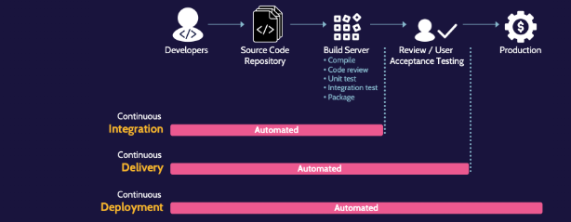

Security of the Software Environments: Most organizations employ the "best practice" of separating specific components within the software development environment.
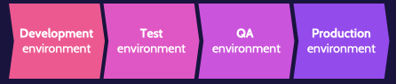
🚨Destination Certification CISSP TLDR 🚨

Database Management System (DBMS): Software that manages data storage, retrieval, and manipulation.
Hardware: Physical servers and storage devices hosting the database.
Software: DBMS applications like MySQL, Oracle, or SQL Server.
Language (e.g., SQL): Used to query and manage data.
Users: People or systems that interact with the database.
Data: Organized information stored and managed by the DBMS.

Relational Database: Stores data in structured tables with rows and columns; uses SQL (e.g., MySQL, PostgreSQL).
Non-Relational Database: Stores unstructured or semi-structured data; uses flexible formats like key-value, document, or graph (e.g., MongoDB, Redis).

Tuple (Row): A single record in a table.
Attribute (Column): A specific data type or category in a table.
Field: Intersection of a row and column; holds one data value.
Primary Key: Unique identifier for each record in a table.
Foreign Key: Field that links to a primary key in another table.

Concurrency: Multiple users or processes accessing the database at the same time.
Locks: Mechanisms to control access and prevent conflicts during concurrent operations.

ACID (For Database Concurrency):
- A = Atomicity: Transactions are all-or-nothing.
- C = Consistency: Transactions bring the database from one valid state to another.
- I = Isolation: Concurrent transactions don’t interfere with each other.
- D = Durability: Committed transactions remain, even after a crash.

🚨Destination Certification CISSP TLDR 🚨

Security should be implemented as EARLY AS POSSIBLE in Software Development

Security should be involved with:
- Risk Analysis and Mitigation
- Auditing and Logging of changes
- Logging and Monitoring
- Internal and External Audit
- Procurement Process
- Certification and Accreditation
- Testing and Verification
- Code Signing

Software Assurance Phases for Acquisition:
- Planning / Requirements
- Contracting
- Acceptance
- Monitoring and Follow-Up

Commercial Off-The-Shelf (COTS): Ready-made software or hardware products available for general purchase and use without custom development.
Pros | Cons
- Product functionality is easily confirmed / verified  - Comparisons of similar products can be made  - Third-Party evaluation of the product can be made  - Existing customers can be contacted  - Software updates and patches are likely more readily available | - Inability to conduct White Box Testing, due to private code base  - Possibility of the Vendor going out of business  - Support and related issues  - Missing features and functionality  - Vulnerabilities being identified and taken advantage of by malicious users as widely used software is more likely to be probed for weaknesses due to the larger user base

Open Source Software: Code is publicly available and can be used, modified, and shared.

Third Party Code: External code integrated into a system, not developed in-house.

Managed Services (MSPs): Outsourced providers that manage IT services and infrastructure for organizations.
🚨Destination Certification CISSP TLDR 🚨

Common Software Security Weaknesses / Vulnerabilities:
Vulnerability / Weakness | Description
Covert Channels | Hidden paths used to transfer information in violation of policy.
Buffer Overflows | Overwrites memory by writing beyond buffer limits.
Memory/Object Reuse | Residual data remains accessible in reused memory.
Executable Mobile Code | Self-contained code (e.g., JavaScript) that runs on a client.
TOCTOU(Race Condition) | Exploits the time gap between checking and using a resource.
Backdoors/Trapdoors | Hidden access methods bypassing normal authentication.
Malformed Input | Unexpected or incorrect input causing application errors or exploits.
Citizen Developers | Non-IT staff who build applications, often without formal training or oversight.

Prevents Buffer Overflow:
ASLR (Address Space Layout Randomization): Randomizes memory addresses to prevent exploit predictability.
Bounds Checking: Verifies input stays within allowed memory limits.

APIs (Application Programming Interfaces): Interfaces allowing systems to communicate.
REST APIs: Use HTTP methods and are lightweight, stateless, and URL-based.
SOAP APIs: Use XML and strict protocols for structured communication.

Coupling: Degree of dependency between components (Lower is better).
Cohesion: Degree to which elements of a module belong together (Higher is better).

Software Defined Security (SDS): Automates and enforces security controls using software across dynamic environments like cloud and virtualization.

Between-the-Lines Attack = Same thing as MITM

